ARTICLE

**Spatial Profiling Reveals Heterogeneity of ILC Subsets in Murine Lung and Intestine Under Type 2 Inflammatory Conditions**

Sandy Kroh 1,2, Anna Pascual-Reguant3, Artür Manukyan4, Ralf Uecker 1,2, Robert Günther, Lars Philipsen5, Ralf Köhler2,6, Peggy Mex7,8, Raluca A. Niesner7,8, Anja E. Hauser 1,2

**Affiliations**

1Charite – Universitätsmedizin Berlin, Department of Rheumatology and Clinical Immunology, 10117 Berlin, Germany.

2 Immune Dynamics, Deutsches Rheuma-Forschungszentrum (DRFZ), a Leibniz Institute, Charitéplatz 1, 10117 Berlin, Germany.

3

4 Berlin Institute for Medical Systems Biology (BIMSB), Max Delbrück Center for Molecular Medicine, Berlin, Germany

5

6 EMBL Node in Single Molecule Science, Department of Molecular Medicine, School of Biomedical Sciences, Faculty of Medicine & Health, University of New South Wales, Sydney, Australia

7

8 .

**ORCID IDs**

Sandy: 0000-0002-3736-3361

Anna:

Artür: 0000-0002-0441-9517

Ralf: 0000-0002-3660-1196

Robert:

Lars:

Ralf:

Peggy: 0009-0005-7567-1313

Raluca:

Anja:

**Corresponding author**

Name, address, email address

**Keywords**

Innate lymphoid cells, IL-33, systemic inflammation model

**Abbreviations**

AL Annotation level

AREG Amphiregulin

CCL C-C motif chemokine ligand

CCR C-C motif chemokine receptor

CD Cluster of differentiation

DAPI 4',6-diamidino-2-phenylindole

EMCN Endomucin

EOMES Eomesodermin

FN Fibronectin

FOV Field of view, tissue region

GATA3 GATA Binding Protein 3

ICOS Inducible T cell co-stimulator

IFNγ Interferon-γ

IL Interleukin

ILC Innate lymphoid cell

ILF Intestinal lymphoid follicle

KLRG1 Killer cell lectin-like receptor G1

LYVE1 Lymphatic vessel endothelial hyaluronan receptor 1

MELC Multiepitope ligand cartography

MHC Major histocompatibility complex

NK cell Natural killer cell

PDGFRα Platelet derived growth factor receptor-α

PDPN Podoplanin

RORγt RAR-Related Orphan Receptor C

Sca1 Stem cells antigen-1

SI Small intestine

TBET T-box expressed in T cells

Th cell T helper cell

TNF-α Tumor necrosis factor-α

**Abstract (max. 200 words)**

Innate lymphoid cells (ILCs) are key regulators of mucosal immunity involved in tissue homeostasis, inflammation, and repair. As rare, tissue-resident immune cells, studying ILCs within their native microenvironment remains challenging. Here, we applied cyclic multiplex immunofluorescence (MELC) combined with a systemic IL-33-induced type 2 inflammation model to characterize ILCs in murine lung and small intestine (SI). We identified and spatially resolved rare ILC subtypes – NK cells/ILC1s, ILC2s, and ILC3s – in both organs, alongside their immune and non-immune neighbors. Spatial neighborhood and co-enrichment analyses revealed conserved ILC2 accumulation in myeloid-rich niches across tissues. In the lung, ILC2s were co-enriched with LYVE1⁺ CD90.2⁺ lymphatics, whereas NK cells/ILC1s localized to perivascular regions near EMCN⁺ CD31⁺ endothelial cells. In the SI, NK cells/ILC1s/ILC3s were enriched near epithelial cells of the crypts under homeostatic conditions; however, IL-33-induced inflammation disrupted this spatial association, redistributing these cells luminally toward the villi. Our findings demonstrate the utility of spatial multiplex imaging for dissecting rare immune cell behavior and uncover dynamic, tissue-specific remodeling of ILC niches during early type 2 inflammation.

**INTRODUCTION**

Innate lymphoid cells (ILCs) are key regulators of inflammation, tissue repair, and immune coordination (1–3) and are generally known as the innate counterpart of T cell subsets sharing transcriptional, phenotypical and functional similarities (4). However, they do not have antigen-specific receptors, but they sense the presence and react upon cytokines, soluble factors, metabolites and ligand-receptor interactions with cellular neighbors in their microenvironment (5–9). There are different ILC subtypes. In short, type 1 ILCs (ILC1) are marked by expression of the master transcription factor TBET, and they secrete IFN-γ and TNFα in the context of type 1 immunity such as intracellular viral and bacterial infections as well as (4). NK cells partly share their marker, cytokine and transcriptional profiles with ILC1s, but represent the cytotoxic branch mirroring the adaptive branch of CD8+ cytotoxic T cells. Like ILC1s, NK cells are involved in intracellular defense in the context of type 1 immunity and are potent producers of IFN-γ and TNF-α (10–12). However, NK cells tend to have higher cytotoxic effector functions secreting granzymes and perforins. Associated with type 2 immunity, ILC2s mirror T helper (Th)2 cells through the expression of high levels of the master transcription factor GATA3 and secretion of type 2 cytokines such as IL-5, IL-9, IL-13 during helminth infection (13). Furthermore, allergic processes such as asthma are associated with ILC2s, as well as chronic fibrotic diseases (14–17). The master transcription factor RORγt defines ILC3s which are potent producers of barrier-associated cytokines such as IL-17A, IL-17F, and IL-22. ILC3s are mainly known for their role in type 3 inflammatory processes such as extracellular pathogens, as well as maintaining barrier integrity (18). Also a part of the ILC family and closely related to ILC3s as they express RORγt are lymphoid tissue-inducer (LTi) cells that are important orchestrators of lymphoid structure formation during embryonic development and beyond (19–22). Although ILCs can be grouped into distinct subpopulations, the subgroups represent heterogenous populations with tissue- and environment-specific variations and adaptations. Through phenotypical, transcriptional and functional flexibility influenced by their current microenvironment, ILCs possess the capacity to change their identity which is known as plasticity (23–27).

ILCs are extremely rare, raising the question of how such scarce cells exert disproportionate immunological influence. One possible answer lies in their spatial organization: their function may depend not only on their presence but on where they are located within the tissue and whom they interact with. Pascual-Reguant et al. have described that human ILCs localize in fibrovascular niches that are conserved throughout different inflamed tissues such as the tonsil and intestines (28). This aligns with publications showing murine ILC2s to localize in adventitial cuffs together with adventitial stromal cells, dendritic cells (DCs) and T regulatory (Treg) cells in various tissues (29). This is an example that highlights how cells are not evenly distributed within the tissue but instead accumulate in micro-anatomical sites together with specific cell types. Those functional hubs that are shaped to support cellular functions such as local inflammation and are also called niches.

While spatial technologies are more often used to study the tumor niche (30–32), the field of immunology has only started to take advantage of spatial information recently (33–36). Additionally, limitations in imaging technologies and analysis pipelines have hindered the study of rare immune populations like ILCs *in situ*. Current knowledge of the spatial distribution of ILCs in mice has used low-plex immunofluorescence technologies, ligand-receptor analysis approaches in single cell data or other functional assays (37–41). Those approaches only enable to visualize either a low number of markers and with this a limited number of cell types or represent an indirect approach missing actual spatial data. Pascual-Reguant et al. have presented an in-depth analysis of human ILCs in multiple organs achieving single cell resolution and the separation of 9 different cell types gaining valuable information about human tonsil ILCs localizing together with plasma cells in a fibrovascular niche sharing functional markers such as IRF4 (28). While studying ILCs in human tissues is essential for uncovering their roles in homeostasis and disease, several challenges limit mechanistic insights. Human sample collection is often constrained by clinical accessibility, and inter-individual variability can obscure specific cellular behaviors or disease-driven mechanisms. In this context, murine models provide a valuable complement: they offer controlled experimental conditions, genetic tractability, and reproducible inflammation models that enable targeted dissection of ILC function. The formation of localized microenvironments has received comparatively little attention until recently (28, 42, 36). This is especially relevant at barrier surfaces such as the lungs and small intestine, where immune responses must simultaneously ensure protection against pathogens and maintain tissue homeostasis.

To address this, we established the multiplex immunofluorescence technology multi epitope ligand cartography (MELC) in murine lung and small intestinal samples and developed an open-source, multiplexed imaging and computational analysis workflow capable of spatially profiling multiple immune cell types – including rare subsets like ILCs – at single-cell resolution. We combined the MELC technology with a systemic inflammation model based on consecutive IL-33 injections. IL-33 is a profibrogenic cytokine associated with type 2 inflammation that is released upon tissue destruction, injury or uncontrolled cell death. IL-33 is also associated with lung fibrosis and triggers a quick activation and expansion of ILC2s in various organs (Li et al., doi: 10.1016/j.jaci.2014.05.011). Most studies investigating ILCs in the context of IL-33–induced inflammation have concentrated on later stages of the immune response (43–45). As a result, little is known about the spatial organization and phenotypic changes of ILCs during the early phase of inflammation—particularly within the first three days. Yet ILCs are known for their ability to respond rapidly to alarmins such as IL-33 and for their strategic localization within barrier tissues. By combining MELC with a systemic IL-33 inflammation model, we are able to characterize ILC subsets, define their spatial niches, and examine both their localization and phenotypic adaptations during the earliest stages of type 2 inflammation. This approach represents a systematic dissection of cellular interactions in tissue-specific niches and offers a powerful tool for studying the spatial logic of mucosal immunity.

**RESULTS**

**Combining cyclic IF with a systemic inflammation model to study ILCs niches in murine lung and SI tissues**

As innate immune cells, ILCs are potent sensors of changes in their microenvironment and are able to shape their surroundings by the potent secretion of cytokines. This makes a spatial characterization of ILCs in the context of inflammation desirable. To this end, we decided to use the multiplex immunofluorescence technique multi epitope ligand cartography (MELC) to analyze tissues from mice in a systemic inflammation model.

First, we designed an antibody panel for MELC with the aim of identifying ILCs, their subtypes, as well as other immune and non-immune cell types that would enable subsequent spatial neighborhood analysis of ILCs (Fig. 1A). As general inclusion markers for ILCs, we established CD127 and CD90.2. The ILC signature transcription factors TBET, GATA3, and RORγt, as well as the NK cell transcription factor EOMES were included to differentiate between ILC1s, ILC2s, ILC3s, and NK cells, respectively. Although we tested various GATA3 antibodies, the resulting staining was either weak or unreliable. ILC2s are described as the predominant ILC subtype in murine lung (46) therefore it is important to include GATA3 in the panel, we decided to use a GATA3eGFP reporter mouse strain. Combining the GATA3eGFP reporter with an anti-GFP antibody resulted in reliable staining of GATA3 in murine lung and intestinal tissues. Additionally, we established other markers that have been previously described in the context of ILC biology (47), as well as markers for immune and nonimmune cells summarized in table 1. Nuclei markers were included in the panel, so that DAPI was stained in the first cycle of MELC, while Sytox Green was stained in the last round of acquisition, and hence, could be used to evaluate tissue quality and integrity of each experiment.

As ILCs only constitute around 0.15 to 1 % of the immune cell compartment in murine lung (46, 48) and as we were not only interested in the spatial distribution of ILCs under homeostatic conditions, but also if and how a potential ILC niche is influenced by inflammatory stimuli, we decided to combine MELC with a systemic inflammation model based on consecutive IL-33 i.p. injections that has been described to trigger a strong type 2 response in various organs and activate ST2+ ILC2s (REF). In preliminary experiments, we acquired a small MELC dataset of murine lung samples 3, 6, and 28 days after IL-33 application and saw a high increase in ILC2s at day 3 of IL-33 application (data not shown). Therefore, we decided to focus on very early time points of inflammation, namely day 1, 2, and 3 after IL-33 injection. 12- to 14-week-old females of GATA3eGFP reporter mice were i.p.-injected with 300 ng IL-33 on up to three consecutive days, organs were isolated 24 hours after the last dose of IL-33 and prepared for MELC (Fig. 1B).

**Major immune and non-immune cells are annotated from cyclic IF data using the Seurat workflow**

We acquired MELC data of murine lung samples 1, 2, and 3 days after IL-33 application as well as healthy controls. After identification of single cells by segmentation, dimensionality reduction and cluster analysis of the lung data resulted in three clusters for the first level of annotation (AL1) and were annotated based on the respective feature profiles (Fig. 2A). Thereby, immune cells showed high levels of the pan-leukocyte marker CD45, as well as different markers for T cells, B cells, plasma cells, and myeloid cells, such as CD3, B220, Kappa, CD68, respectively. The cluster annotated as endothelia & stroma was high in endothelial and fibroblast-associated markers EMCN, CD31, LYVE1, PDPN, Sca1, and PDGFRa, while the cluster annotated as epithelia was marked by a high level of EpCAM and CD138.

For visual validation, the annotated cell types, namely immune cells (dark cyan), stromal cells (dark magenta), and epithelia (gold), of each FOV were depicted in x and y (Fig. 2 B) and were compared to the respective MELC IF overlays of CD45 (cyan), CD31 (magenta), and EpCAM (yellow) showing correlating distribution patterns (Fig. 2C).

**Three ILC subtypes are resolved and ILC2s represent the predominant subtype in murine lung tissue**

To increase the granularity and identify ILC subtypes, we analyzed the clusters by only including markers that were associated with the respective cell type of interest in the dimensionality reduction and cluster analysis. This approach enabled us to separate a CD3- CD127+ CD90.2+ cluster of ILCs with high levels of GATA3eGFP and KLRG1 from other immune cell types like T helper cells, T cytotoxic cells, myeloid cells, and B cells & plasma cells in AL2 (Fig. 3A). We were able to identify three ILC subtypes and annotate the clusters based on their feature profiles as NK cells/ILC1s, ILC2s, and ILC3s (Fig. 3B). Visual validation of the annotated ILC subtypes with respective ILC-related markers using IF overlays was performed and confirmed correct annotation (Fig. 3C-E). Of note, visual validation included the presence of a nuclei signal, evaluation of a lymphocyte-like shape and the presence of subtypes specific IF signal described in more detail in the following section. All three clusters showed high levels of GATA3eGFP (median over 6) (Fig. 3B). Both ILC2s and ILC3s had intensity levels of both CD127 and CD90.2 that had a median of around 6 while identified NK cells/ILC1s had lower or no levels of both markers with medians of 0. Furthermore, ILC2s showed the highest levels of GATA3eGFP and KLRG1 with medians of 6.3 and 6.2, respectively (Fig. 3B, Fig. 3C). NK cells/ILC1s only partly showed CD127 and CD90.2 but were the ILC cluster with the highest levels of TBET and EOMES. The median of EOMES was 6.4 while both ILC2s and ILC3s had a median of 0. With 6.5 in NK cells/ILC1s, the median of TBET was even higher. Partly, also ILC3s showed TBET signal (median = 4), while ILC2s had a TBET and EOMES median of 0 (Fig. 3B, 3D). The cluster annotated as ILC3s had a high median of RORγt (6.2), while the median of ILC2s and NK cells/ILC1s was 0.

We also performed re-clustering of the stromal compartment which resulted in three subtypes: EMCN+ CD31+ blood vessels, LYVE1+ CD90.2+ lymphatics, and a CD45- IRF4+ cluster. In summary, we were able to identify 11 different immune and non-immune cell types in murine lung MELC data, including the ILC subtypes NK cells/ILC1s, ILC2s, and ILC3s (Supplementary Fig. 1).

**Lung ILC2s are the predominant ILC subtype in murine lung and only increase at IL-33 day 3**

We first quantified the total count, as well as the proportions of the identified ILC subtypes within the immune and the ILC compartment under homeostatic conditions (Fig. 4A-C). The median number of identified ILC2s per FOV was 11, while the median number of NK cells/ILC1s was 8 (Fig. 4A). ILC3s were the rarest ILC subtype and were only detected in one out of 9 FOV under homeostatic conditions (Fig. 4A). Regarding the different ILC subtypes, ILC2s represented the predominant ILC subtype within the immune compartment with a median of 4.5 % as well as within the ILC compartment with a median of 61.5 %, followed by NK cells/ILC1s (median of 3.7 % and 38.5 %, respectively). ILC3s were only detectable in one FOV under homeostatic conditions and ILC3s were present in frequencies of less than 1 % (Fig. 4B-C).

Next, we quantified the cellular distribution at different time points after IL-33 application (Fig. 4D-I). Comparing the time points after IL-33 injection to the controls revealed already a significant increase in the total count of the analyzed cells per FOV in general at IL-33 day 1 (Fig. 4D), as well as the immune cells (Fig. 4E), and ILCs (Fig. 4F). However, a strong, statistically significant increase compared to homeostatic tissue was observed after three doses of IL-33. Of note, there was also an increase in myeloid cells from a median count of 51 under homeostatic conditions to 383 IL-33 day 3 (data not shown).

Looking at the ILC compartment, the total counts of NK cells/ILC1s (Fig. 4G), ILC2s (Fig. 4H), and ILC3s (Fig. 4I) significantly increased at day 3 after IL-33 treatment, compared to healthy controls. There was no significant change in the frequencies within the ILC compartment, except for the ILC3 frequency significantly increasing to a median of 8 % at IL-33 day 2, compared to healthy controls where those cells were undetectable (data not shown).

These data confirmed that ILC2s represented the predominant ILC subtype in murine lung tissue. The application of IL-33 significantly triggered the accumulation of cells in general, immune cells and all ILC subtypes in the lung at IL-33 day 3.

**Spatial analysis reveals accumulation of ILC2s in peri-lymphatic niches shared with myeloid cells in the lung**

Next, we analyzed the localization of the different ILC subtypes at different points after IL-33 application to interrogate whether the inflammatory stimuli affected the distributions of ILC subtypes within the tissue.

Spatial analysis revealed high co-enrichment scores of ILC2s and lymphatics (Fig. 5A). This was confirmed by visual inspection and localization of ILC2s close to CD90.2+ LYVE1+ endothelial structures that represented lymphatics in IF overlays (Fig. 5B). Of note, the identified ILC2s were localized close to lymphatics but only rarely inside vessel structures confirmed quantitatively by 98.08 % of ILC2s having a minimum distance to lymphatics higher than 5 µm under homeostatic conditions (data not shown). ILC2s possessed with a median of 33 µm the smallest minimum distance to lymphatics within all measured immune cells under homeostatic conditions in murine lung (Fig. 5C). At IL-33 day 3, an overall decrease of the minimal distance of all tested different immune cells to lymphatics was observed. With 26 µm, ILC2s showed the smallest minimum distance (Fig. 5D). The cells in neighborhood (CIN) analysis revealed that within a 15 µm radius around ILC2s, lymphatics represented 4 % under homeostatic conditions and 6 % at IL-33 day 3 (Fig. 5E). 6 % was the highest proportion of lymphatics in the CIN measured for any cell type. Of note, ILC2s and lymphatics were both rare cell types and were present with frequencies of 1-4 % within all identified cells, while blood vessels represented one of the most abundant cell types with frequencies of over 40 %.

Besides the co-enriched localization of ILC2s with lymphatics, spatial analysis also showed spatial association of ILC2s with myeloid cells (Suppl. Fig. 2A) and ILC2s (Suppl. Fig. 2B). This went in line with high proportions of both myeloid cells and ILC2s in a 15 µm radius around ILC2s observed in the CIN analysis of ILC2s (Supp. Fig. 2C) that showed that both ILC2s and myeloid cells made up around 50 % of the ILC2 niche. The median proportion of myeloid cells in a 15 µm radius around ILC2s increased from 11 % under homeostatic conditions up to 23 % at IL-33 day 3 (Supp. Fig.2C). Additionally, IF overlays showed ICOS+ ILC2s in direct contact with CD68+ myeloid cells (data not shown). We did not find a global pattern of co-enrichment of ILC2s with other immune and non-immune cell types like T helper cells (Suppl. Fig. 2D).

Taken together, our data supports the accumulation of ILC2s in a peri-lymphatic niche in the lung shared with myeloid cells.

**Lung NK cells/ILC1s accumulate in peri-vascular tissue areas**

Next, we analyzed the spatial distribution of the identified NK cells/ILC1 cluster. Unlike ILC2s that showed to be spatially enriched close to lymphatic vessels, NK cells/ILC1s were co-enriched with EMCN+ CD31+ endothelial blood vessels (Fig. 6A). Of note, blood vessels were with over 40 % the most abundant cell type identified, while NK cells/ILC1s constituted only 0.9-1.3 % of the identified cells. However, the minimal distance of NK cells/ILC1s to blood vessels was only 10 µm under homeostatic conditions which was significantly less compared to ILC2s and myeloid cells (Fig. 6B). This distance even decreased to only 7 µm at IL-33 day 3, which represented a significant difference compared to all other immune cell types (Fig. 6C). The distribution of NK cells/ILC1s away from lymphatics, in peripheral tissue areas marked by endothelial blood markers was confirmed visually by IF overlays (Fig. 6D). Unlike ILC2s, NK cells/ILC1s did not localized close to myeloid cells and were ICOS-/low (data now shown). We did not find a predominant pattern of spatial co-enrichment of ILC3s with another cell type (data not shown).

Our data shows a difference in the spatial niche of NK cells/ILC1s localizing in peri-vascular tissue areas of the murine lung compared to ILC2s sharing a peri-lymphatic niche with myeloid cells suggesting different functional spatial neighborhoods of ILC subtypes.

**ILC2s and a mixed cluster of NK cells/ILC1s/ILC3s are resolved in murine SI tissue**

We used the same approach for identifying and annotating cell types as in the lung dataset. In AL1, we separated major cell types, namely immune cells, stromal cells and epithelia (Suppl. Fig. 3A) and performed visual validation using IF overlays (Suppl. Fig. 3B). Re-analysis of the different identified clusters separately enabled us to resolve two epithelial clusters, namely epithelia I and epithelia II; 3 stromal/endothelial clusters, namely lymphatics, blood vessels and fibroblasts; and the immune cell types, myeloid cells, B cells and plasma cells (Fig. 7A, Suppl. Fig. 4A-B).

In order to differentiate ILCs from T cells, we combined the cells from the mixed ILC/T cell clusters and applied a threshold on the intensity level of CD3 (Fig. 7B). Re-clustering of the CD3+ and CD3- populations separately resulted in ILC/NK cell and T cell clusters annotated based on the respective feature profiles (Fig. 7C). Cytotoxic T cells showed CD3 as well as high levels of CD8a, while T helper cells were also CD3+ but with high levels of CD4. In one CD3- cluster, 67 % of cells were EOMES+. Furthermore, additional markers defined the profile of this cluster, such as CD127, CD90, CD4, and RORγt, which were expressed by 67 %, 59 %, 38 %, and 50 % of the cells (Fig. 7C; Suppl. Fig. 5). Therefore, the cluster was annotated as ILC1s/ILC3s/NK cells. With 86 % of the cells being GATA3eGFP+, 72 % CD90.2+, and 46 % CD127+ in the absence of CD3, the other ILC cluster possessed an ILC2 phenotype (Fig. 7C; Suppl. Fig. 6). We also identified one cluster that showed no levels of CD3 but high levels of CD8a, and partly CD90.2. Visual inspection revealed an intra-epithelial localization of those cells and the round shape of lymphocytes (Suppl. Fig. 7). Therefore, we annotated them as CD8+ CD3- intra-epithelial lymphocytes (IEL).

**Intestinal ILC2s increase after one dose of IL-33**

In the SI, the acquired tissue regions showed two predominant micro-anatomical structures, namely intestinal villi and intestinal lymphoid follicles (ILF) located in the lamina propria. Based on this, we grouped the acquired FOVs in SI villi (Suppl. Fig. 7A) and SI ILF (Suppl. Fig. 7B) and quantified the data separately. First, we quantified the proportion of ILC subtypes.

As expected, compared to the lung in steady state, both SI villi and SI ILF tissue regions harbored significantly higher numbers of total cells, immune cells, and ILCs, with the highest total counts in SI ILF tissue regions (Suppl. Fig. 9A-C). Of note, the frequency of ILCs within the immune compartment did not differ significantly between organs and tissues (Suppl. Fig. 9D). The highest counts of ILCs, and the identified subtypes were detectable in the SI ILF regions (Suppl. Fig. 9C). Zooming into the ILC subtypes identified in the SI revealed frequencies of NK cells/ILC1s/ILC3s and ILC2s between 40 and 60 % within the ILC compartment in both SI villi and SI ILF (Suppl. Fig. 9E-F).

Quantification of the SI villi data at the different conditions showed that the total cell number as well as the total immune cell number significantly decreased after one dose of IL-33 compared to healthy controls in SI villi regions (Fig. 8A-B) while the number of ILCs was only significantly reduced at IL-33 day 3 (Fig. 8C). However, although the total number of immune cells identified per FOV decreased at IL-33 day 1, the frequency of immune cells rose significantly at the same time (Fig. 8D). Looking at the ILC frequency within the immune compartment only showed an increasing trend at IL-33 day 1 (Fig. 8E). At IL-33 day 3, not only was the total ILC count significantly reduced, but also the frequency of ILCs as well as the frequencies of ILC subtypes, namely NK cells/ILC1s/ILC3s and ILC2s within the immune compartment (Fig. 8E-G).

Like lung ILC2s, spatial analysis of ILC subtypes in SI villi regions revealed co-localization of ILC2s with myeloid cells (Fig. 8H-I). We did not observe a significant pattern of co-enrichment of ILC2s and lymphatics or fibroblasts, although IF overlays suggested a spatial association (data not shown). Analyzing the spatial distribution of NK cells/ILC1s/ILC3s, we did not observe co-enrichment of NK cells/ILC1s/ILC3s with any other immune cell type, as well as fibroblasts, blood vessels, lymphatics and epithelia I cells under any analyzed conditions (data not shown). However, co-enrichment analysis revealed spatial association of the NK cells/ILC1s/ILC3s and epithelia II cells under homeostatic conditions (Fig. 8K). Besides strong signal of EpCAM, the epithelia II cluster was also marked by high intensities of Ki67, as well as Sca1 and CD44 (Fig. 7A) which, together with IF overlays (Suppl. Figure 8) pointed towards a cluster identity of epithelial cells of the basal area of the villi including the crypts and intestinal stem cells (ISC), and a spatial separation from the cells of the epithelia I cells. The pattern of co-enrichment of NK cells/ILC1s/ILC3s and epithelia II cells was resolved after one dose of IL-33 pointing towards a spatial re-distribution of NK cells/ILC1s/ILC3s during inflammation, which was confirmed by visual inspection in the IF overlays (Fig. 8K-M). Together, these data highlight region-specific alterations in ILC abundance and spatial organization within the small intestine during early type 2 inflammation, with ILC2s maintaining proximity to myeloid cells, and NK cells/ILC1s/ILC3s undergoing a marked spatial redistribution towards the luminal part of the villi.

In summary, our MELC-based spatial and phenotypic framework enables unprecedented single‑cell resolution of rare ILC subsets and their dynamic niche remodeling during early IL‑33‑driven inflammation laying the foundation for targeted interventions in barrier tissue immunopathology.

**DISCUSSION:**

This study used multiplex cyclic IF, namely MELC, to identify ILCs and ILC subtypes in murine lung and SI tissue under homeostasis and investigate their adaptations during an IL-33 triggered inflammation. While most studies using spatial multiplex approaches focus on either highly abundant immune cells, often T cells and B cells in the context of tumors, we were interested in establishing a workflow that (I) is able to spatially resolve abundant cells as well as rare cell types in the tissue and (II) enables to perform spatial neighborhood analysis to identify conserved or tissue-specific distribution patterns of cells and (III) use this approach for investigating mechanisms of tissue immunity. Thereby, we were especially interested in ILCs, rare innate immune cells that are tissue-resident and quickly react to changes in their microenvironment as potent orchestrators of immunity in various tissues.

We established a 40+ marker panel for MELC in murine lung and SI and analyzed samples collected from GATA3eGFP mice challenged with up to three doses of IL-33 on consecutive days representing a systemic type 2 inflammation model. Using an adapted and optimized image and data analysis workflow consisting of a combination of open-source software, we were able to annotate different ILC subtypes in both organs as well as other immune and non-immune cell types (11 cell types in the lung and 13 in the SI data). Thereby, all identified ILC subtypes expressed different levels of GATA3eGFP, but the identified ILC2s showed the highest levels of GATA3eGFP. This aligns with the essential role of GATA3 and the heterogenous levels expressed during the development of all CD127+ ILC subtypes, as well as the fact that GATA3 expression only remains important for the maintenance of ILC2 identity and function (49, 50). Significant changes in the ILC composition in both organs were already observable at early time points of inflammation, namely day 1 and 3 after IL-33 injections. Spatial co-enrichment analysis revealed a peri-lymphatic localization of lung ILC2s and a shared niche of ILC2s with ILC2s and myeloid cells in both organs lung and SI. In contrast, lung NK cells/ILC1s did not localize together with lymphatics but in peri-vascular niches surrounding blood vessels. Co-enrichment of intestinal NK cells/ILC1s/ILC3s with other immune and non-immune cells was only observable for NK cells/ILC1s/ILC3s and cells of the basal part of the villi including the crypts comprised in the cluster annotated as epithelial II cells under homeostatic conditions, but not after IL-33 application.

Our spatial analysis confirms a broncho-vascular localization of ILC2s in the lung described by Dahlgren et al. (29), but our co-enrichment analysis and visualizations additionally show high co-enrichment scores of ILC2s and LYVE1+ CD90.2+ lymphatics pointing towards a more specific peri-lymphatic ILC2 niche. Furthermore, lung ILC2s and ILC3s but not NK cells/ILC1s show ICOS levels. ICOS regulates ILC2 homeostasis independently of T cells and B cells and is required for the proliferation and accumulation of mature ILC2s in the lungs and intestines (51). It has been shown that ICOS+ ILC2s are crucial for tissue protection during the early time points of bleomycin-induced lung injury, PR8 influenza infection and LPS airway challenge (52) as well as intra-nasal application of IL-33 (51), but this has not yet been shown for the *i.p.* IL-33 systemic inflammation model. Furthermore, ILC2s colocalize with myeloid cells. Identified myeloid cells in our study expressed high levels CD68, CD11c and MHC II and most likely represent both alveolar macrophages and dendritic cells (53). A shared niche of ILC2s and myeloid cells that our spatial co-enrichment analysis revealed suggests an interaction as described by Hrusch et al. at early time points of bleomycin-induced lung inflammation. This is especially interesting as in the same study increased ICOSL levels have been found in alveolar macrophages (52).

Quantification of the ILC2s in our lung data resulted in a frequency of ILC2s of about 5 % within the immune compartment under homeostatic conditions. This was much higher than expected. In general, the number of ILC2s highly depends on age, sex, and other environmental conditions (54), but in murine lungs, it is considered very low, e.g. Sadeghalvad et al. report an ILC2 frequency of around 0.15 % within the immune cell compartment of homeostatic murine lung (48). One explanation for those differences might be the region selection, where we focused on vessel and epithelial structures. Co-enrichment analysis and visual inspection showed that ILC2s accumulate close to lymphatics – a distinct microanatomical niche. An increased frequency of ILC2s in those micro-anatomical peri-lymphatic niches may explain how rare cell types can have an important impact on the tissue scale. It also highlights the importance of spatially resolved studies of cells in the tissue context as this information gets lost during dissociative procedures. Co-enrichment of ILC2s, lymphatics, and myeloid cells also aligns with studies describing an interplay of those cell types (55–59). For instance, lung ILC2s stimulate lymphatics (but not blood endothelial cells) to upregulate CCL21 via LIF-LIFR, providing a crucial migratory signal for CCR7+ immune cells (58). Our findings support the idea of a strategic positioning of ILC2s together with myeloid cells and lymphatics in a functional niche in lungs.

Interestingly, our analysis show that while lung ILC2s reside in peri-lymphatic niches, identified NK cells/ILC1s from the lung did not localize close to lymphatics but are co-enriched with endothelial blood vessels that are marked by EMCN and CD31. Lung NK cells and ILC1s have both immunomodulatory functions and pathological roles (60). Both ILC1s and NK cells are potent producers of IFNγ. ILC2s have been reported to express IFNγR, and are responsive to IFNγ secreted by ILC1s and NK cells, e.g. in the context of viral infection (61, 62). It has been shown that IFN-γ is a counter signal to IL-33 that inhibits ILC2 activation and suppresses type 2 immunity in the context of IL-33-induced inflammation in mice (63). While this is important for taming type 2 inflammatory processes after an acute phase or mixed type 1 and 2 inflammation, spatially distinct tissue niches of ILC2s and NK cells/ILC1s under non-inflammatory conditions may represent a natural safety mechanism to avoid unwanted interactions and with this, potential negative effects as well as perturbations during homeostasis that might lead to chronic inflammation.

A conserved fibrovascular niche of ILCs in different chronically inflamed human tissues has been described by Pascual-Reguant et al. (28). We acquired data of murine lung and SI from the same mice in order to investigate conserved or tissue-specific spatial and phenotypical patterns of ILCs. While analysis of the cell types and ILC subtypes worked well on the lung data, in general, data analysis was more challenging in the SI tissue and required additional steps, for instance, to separate ILC subtypes and T cell subtypes. This was most likely because of the more severe tissue destruction that has been described in the intestines for *i.p.*-application of IL-33 (44, 43). This might also explain that the co-enrichment analysis showed lower enrichment scores compared to the lung, e.g. for ILC2s and myeloid cells. ILC2s Dahlgren et al. describe a perivascular niche of ILC2s in the small intestine where they reside together with IL-33+ stromal cells in adventitial cuff structures (29). Although we identified a cluster of fibroblasts that PDPN, Sca1, and visually they localized close to FN+ tissue structures, we did not detect a pattern of co-enrichment through the analysis. An additional explanation may be the diversity of subtypes of fibroblasts and stromal cells (64, 65) that may not be resolved by the used marker panel. It has been shown that IL-33-activated ILC2s induce collagen production from fibroblasts (55), so additional investigations with spatial technologies with a panel focusing on an ILCs and fibroblasts would be interesting.

We were able to resolve two clusters of ILC subtypes in the SI data. The mixed cluster of NK cells/ILC1s/ILC3s could probably not be separated into NK cells, ILC1s and ILC3s due to the exclusion of TBET from the analysis panel, which represents the signature transcription factor of ILC1s. Additionally, NK cells, ILC1s, and ILC3s share a lot of markers, such as NKp46 (66) and have overlapping marker profiles that are highly depending on tissue, organ and environmental factors (67, 68). Furthermore, ILCs are known for their high degree of plasticity, with various examples of ILC1-to-ILC3 conversion and vice versa in various organs and in the context of inflammation (69–71). NK cells/ILC1s/ILC3s are co-enriched with epithelial II cells under homeostatic condition but this co-enrichment is resolved after one dose of IL-33. Epithelial II cells represent the epithelial layer of the basal part of the villi including the crypts which harbor ISCs being highly proliferative (72). Small intestinal organoids co-culture with ILC1s for 4 days has been shown to increase the transcriptional CD44-expression in epithelial cells, and enlarged CD44+ crypt buds are built in the presence of ILC1s, with identified signature genes in ILC1s suggesting extracellular matrix remodeling driven by TNF-α (73). Besides EpCAM and Ki67, the epithelia II cluster showed high levels of CD44 and Sca1, which may suggest that NK cells/ILC1s/ILC3s are involved in shaping microanatomical tissue architecture and the ISC niche as described in organoids but would require further investigations. Furthermore, ILC3s are closely associated with gut homeostasis. ILC3s obtain a proactive role towards ISC after epithelial tissue damage and IL-22 expressed by ILC3s is one of the factors important for the maintenance of ISC afterwards (74). Intestinal ILC3s are also directly involved in the DNA damage response of ISC regulating this by IL-22 secretion (75).

With MELC, we only studied adaptations of ILCs on the protein level. However, as fast responders at early time points of inflammation, it may be interesting to study potential changes also on the transcriptional level using spatial transcriptomics. This would complement the limitations of MELC in staining cytokines in the tissue and gain additional information about cell communication within the niche. A combined approach of spatial proteomics and spatial transcriptomics data (76, 35) with single cell resolution of rare ILCs may help to confirm local interactions of ILC2s, lymphatics and myeloid cells in the peri-lymphatic niche by receptor-ligand interaction analysis and to further define niche-specific fingerprints. Spatial technologies have the potential to add another dimension of understanding to cellular processes – namely how local niches drive immune pathologies (35, 77).

Overall, our study provides a workflow to study rare immune cells and their micro-environment in the context of inflammation and in the tissue. It reveals subtype-specific tissue niches of ILCs that are partly conserved between murine lung and SI, namely a shared niche of ILC2s and myeloid cells. Analysis of cells on a tissue-scale using spatial multiplex approaches with single cell resolution as presented here will help to unravel local interaction mechanisms that shape the outcome of immunity and pathology.

**Limitations (maximum 250 words)**

From a technical perspective, working with imaging-based data points up several challenges. Due to the nature of tissue architecture, e.g. densely packed cells or tissue destruction from acute inflammatory events, there is the problem of spatial-cross contamination in imaging-based data compared to dissociative methods such as single cell-sequencing or flow cytometry. Fixed gating strategies are often problematic as thresholds and gates of individual cells are influenced by spatial-cross contamination of directly neighboring cells. This is additionally influenced by the quality of segmentation. Here, we used a combination of pixel classification, segmentation, and feature extraction. This approach was highly time-consuming. Using pre-trained AI models (78, 79) has the potential to both reduce the time and enhance the quality and accuracy of the segmentation. Unfortunately, those models often cannot deal with more challenging structures, such as densely packed, inflamed tissues or non-round, complex stromal cells. Newer tools give the possibility to fine-tune existing models on the datasets (80) or enhance image quality (81). Although this reduces the time of training, several hours to days still must be invested. Manual visual inspection remains a crucial validation approach when dealing with imaging-based data but is also very time-consuming. This study used a 2D approach for the spatial analysis of ILCs. However, as tissues are 3D structures, 3D approaches such as light sheet microscopy have the potential to identify hidden complex structures and cellular networks (82–84), especially for rare cell types.

**MATERIAL AND METHODS**

**Mice**

**Ethical statement**

The research presented in this manuscript complies with all relevant ethical regulations. All experimental procedures involving animals were carried out after approval of the study protocols by the Landesamt für Gesundheit und Soziales Berlin (LaGeSo), animal license number (G0122/20). Mice used for this study were kept in the animal facilities of the DRFZ under specific pathogen free conditions, which included the maintenance of a 12-h light/dark cycle with the ambient temperature set to 22 ± 2 °C and air humidity 55 ± 10% rH. Food and autoclaved water were provided *ad libitum.*  The housing of the animals were cages that were individually ventilated (IVCs) and contained an enriched environment. Animal experiments were conducted following the 3 R Principles: replace, reduce, refine. Mice were handled using tunnels to reduce stress and anxiety.

**IL-33 application**

Female 12- to 14-week-old GATA3-enhanced green fluorescent protein (eGFP) reporter mice (85) were i.p.-injected with 300 ng recombinant carrier-free mouse IL-33 (Biolegend, San Diego, USA) solved in 0.1 to 0.5 ml sterile saline on up to three consecutive days. The mice were inspected and weighted on a daily basis.

**Organ isolation and tissue preparation**

Mice were sacrificed after none, 1, 2, or 3 doses of IL-33, 24 hours after the last dose. Approximately 1.5 hours before killing the mice, *intra-venous (i.v.)* administration of 200 mg/kg bodyweight Pimonidazole (Hypoxyprobe, Burlington, USA) was performed. Mice were anesthetized and perfused with 1 % freshly prepared electron-microscopy grade paraformaldehyde (PFA) (EMS, Hatfield, USA) solution. The SI was isolated and flushed extensively with 50 ml Phosphate Buffered saline (PBS) using a syringe before incubation in freshly prepared 1 % PFA in PBS solution for three hours at 4 °C. The lungs were isolated still connected by the trachea, and incubated for three hours in 1 % PFA solution at 4 °C. The PFA solution was discarded, and the samples rinsed with cold PBS for 2-5 min on ice. Afterwards, the organs were incubated in 15 % sucrose solution at 4 °C. After 6 to 12 hours, the sucrose solution was discarded and the samples were put into 30 % sucrose solution for 6 to 12 hours at 4 °C. Lung samples were prepared by inflating the lungs through the trachea with 1:2 PBS:Tissue-Tek O.C.T. Compound (Sakura) solution using a syringe and carefully put into prefilled cryomolds containing O.C.T. medium. To prepare the SI for freezing, the SI was cut into three equal parts. Each part was then slid on blunt scissors and carefully cut longitudinally. Swiss roll samples were prepared (86) and carefully put into cryomolds filled with O.C.T. medium.

**Cyclic IF: Multi epitope ligand cartography (MELC)**

**Tissue Preparation**

Fresh frozen tissue was cut 5 µm thick with a NX80 cryotome (ThermoFisher, Waltham, Massachusetts, USA) on 3-aminopropyltriethoxysilane (APES)-coated cover slides (24 × 60 mm; Menzel-Gläser, Braunschweig, Germany). Samples were fixed for 10 min at room temperature using a freshly opened EM grade PFA ampulla (methanol- and RNAse-free; Electron Microscopy Sciences, Hatfield, Philadelphia, USA) diluted to 2%. After washing three times with PBS, samples were permeabilized with 0.2% Triton X-100 in PBS for 10 min at room temperature. Subsequently, a blocking step with 10% goat serum and 1% BSA in PBS was performed for at least 20 min. Afterwards, a fluid chamber holding 100 μl of PBS was created using “press-to-seal” silicone sheets (Life technologies, Carlsbad, California, USA; 1.0 mm thickness) with a circular cut-out (10 mm diameter), which was attached to the coverslip, surrounding the sample.

For every MELC run, a bottle of fresh PBS with 1% BSA and 0.02% Triton X-100 was used. The sample was placed on the sample holder and fixed with adhesive tape followed by accurate positioning of the binning lens, the light path, as well as Köhler illumination of the microscope.

**Image Acquisition**

The data was acquired using a modified Toponome Image Cycler Mm3 (Tic) (Meltec GmbH & Co. KG, Magdeburg, Germany) and a BioDecipher Device 1.0 (BioDecipher GmbH, Magdeburg, Germany). Details of equipped components are summarized in supplementary table 1.

MELC image acquisition consists of 4 steps that are repeated in cycles: (1) Antibody incubation for 15 to 55 mins and 30 automatic washing steps; (2) Image acquisition of up to 4 channels of 3 previously selected FOVs; (3) Photo-bleaching of 5 to 30 mins of each FOV; (4) Image acquisition of the bleaching image for every selected FOV. During image acquisition, image stacks of 10 in both positive and negative z-dimension were acquired sized 2048 x 2048 pixels, where each pixel represented 0.325 µm.

**Antibody Panel**

All antibodies used for this study were titrated for the optimal dilution in murine lung and SI samples and are summarized in Supplementary table 2. Optimal order of the antibodies was determined by test experiments. Steric hindrance issues that might appear due to this specific labeling order have been ruled out as previously shown.

For each experiment, 60 µl of freshly prepared antibody dilution was pipetted in a 96-well plate.

**Image Pre-processing**

Image preprocessing of the Tic MELC data was performed as previously described (Pascual-Reguant et al. 2021). For the MELC data acquired with the BioDecipher device, the implemented TICobserver software (BioDecipher GmbH, Magdeburg, Germany) was used. Both approaches comprised image registration, background subtraction, and illumination correction, and achieved comparable results. Image normalization was performed in Fiji ImageJ (87, 88) just as described in previous publications, and included background estimation (rolling ball algorithm), edge removal, as well as image intensity scaling (89, 28, 35). Each staining was manually examined for artefacts and excluded when major auto-fluorescent artefacts covered a dominant area of the stained tissue. If a minor artefact was located in a part of the image, where there was no tissue or only covered an area of up to 10 cells, the artefact was cut out from the image and standardization was re-applied.

**Pixel classification using Ilastik**

Pixel classification was done using Ilastik (90). The integrated random forest algorithm was trained based on the IF overlay depicting the nuclei (DAPI or Sytox) and a Z-projection of selected membrane markers (EpCAM, CD45, CD44, CD11c, CD4, LYVE-1, podoplanin (PDPN), Sca1, CD68, platelet derived growth factor receptor-α (PDGFRa), CD138, fibronectin (FN), sialic acid binding Ig-like lectin F (SiglecF), and Kappa) to classify pixels into Nuclei, Cytoplasm, and Extacellular matrix (ECM). Training was performed separately for lung and SI data. Visual inspection and minor adjustments of each FOV resulted in optimized probability maps for Nuclei, Cytoplasm and ECM that were exported.

**Segmentation and feature extraction**

Probability maps created with Ilastik together with 16-bit greyscale images were used as input for CellProfiler 4.0 (91) for segmentation of nuclei and cells, as well as for feature extraction and data export. For each FOV of a MELC experiment, the probability maps for Nuclei, Cytoplasm and ECM created in Ilastik, as well as all single marker images standardized, and intensity adapted were used as input in CellProfiler. Before the actual segmentation, image subtraction was performed by subtracting the ECM probability map from the nuclei probability map as well as from the cytoplasm probability map using CellProfiler’s ImageMath module. Subsequently, the subtracted nuclei image was used for segmentation of nuclei as primary objects with the module IdentifyPrimaryObjects with advanced settings.

By applying an adaptive thresholding strategy and a two class Otsu as the thresholding method segmentation of nuclei was achieved. Using the identified primary objects (nuclei) as seed points and similar settings as for the primary objects, secondary objects were identified by running the IdentifySecondaryObjetcs module. The identified secondary objects represented cells. Tertiary objects, named cytoplasm were created by subtraction of nuclei (primary objects) from cells (secondary objects) implemented in the IdentifyingTertaryObjects. In case that the segmentation outcome did not pass manual inspection, an additional step using the module EditObjectsManually was conducted, where under-segmented, clothed cell clumps and over-segmented cells were manually refined.

For each identified object, median fluorescence intensity (MFI) of nuclear markers was measured in the respective primary object (nucleus), while the MFI of all other markers was measured in the respective secondary object (cell). Resulting from the applied CellProfiler pipeline, the measured single cell features of all objects together with the respective spatial information of the X- and Y-coordinates of the nuclei were exported as csv files.

Complete and detailed CellProfiler pipelines and all data tables generated are publicly available in the Zenodo open access repository https://zenodo.org/ (see “Data availability”).

**Data analysis**

Data analysis was performed using R (92) and RStudio (RStudio: Integrated Development for R. RStudio, PBC, Boston, MA URL <http://www.rstudio.com/>) version 2023.06.1. Used packages and versions are summarized in Supplementary table 3.

As sometimes not all the markers passed the quality check during the image processing steps, only markers that worked in at least 90 % of the acquired MELC datasets were used for subsequent analysis. In murine lung, AREG, B220, CCR6, CD117, CD11c, CD127, CD138, CD3, CD31, CD4, CD44, CD45, CD68, CD8a, CD90.2, endomucin (EMCN), epithelial cell adhesion molecule (EpCAM), ICOS, KLRG1, Kappa, LYVE-1, MHC II, NKp46, PDGFRα, PDPN, Sca1, EOMES, GATA3, GATA3eGFP, IRF4, antigen Kiel 67 (Ki67), RORγt, and TBET have been used for downstream analysis. CD134, FN, Gr-1, IL-10, IL-25R, NK1.1, programmed cell death protein 1 (PD1), ST2, CD115, CD200, CD24, CXCR6, SiglecF, vasoactive intestinal polypeptide (VIP), forkhead box protein 3 (FoxP3), intercellular adhesion molecule 1 (ICAM-1), CD122, GZMA, Perforin, vascular cell adhesion molecule 1 (VCAM-1), inhibitor of DNA binding 2 (Id2), promyelocytic leukemia zinc finger (PLZF), piezo-type mechanosensitive ion channel component 1 (Piezo1), and IL-33 were excluded from the lung and SI MELC data analysis as they did not pass the quality criteria. In murine SI, AREG, CCR6, CD117, CD11c, CD127, CD3, CD4, CD44, CD45, CD8a, CD90.2, EMCN, EpCAM, KLRG1, Kappa, LYVE-1, MHC II, NKp46, PDGFRα, PDPN, Sca1, EOMES, GATA3eGFP, IRF4, Ki67, and RORγt passed those criteria and were used for downstream analysis. Besides the already mentioned excluded markers in the SI, TBET, CD138, CD31, CD68, and ICOS were also not included. Of Note, markers that were excluded due to not passing the 90 % criteria were still available and useful for the creation of overlays and visual validation of analysis results. Thresholding

Hyperbolic arcsine (arcsinh) transformation using a cofactor of 2 was applied on the extracted feature data (Wolfram Research (1988), ArcSinh, Wolfram Language function, https://reference.wolfram.com/language/ref/ArcSinh.html; updated 2021)

The following strategy was applied for filtering out low-quality cells: (A) First the maximum feature value (MFV) from all measured features was identified for each cell; (B) The MFV was visualized in a histogram; (C) The first derivative of the MFV was calculated using the following formula:

∆y=y_(i-1)-y_i (1)

with i∈{1,…,N},N is the maximum value of all MFV,

where ∆y represents the change in y from y_(i-1) to y_i; (D) The alteration of the sign of the first derivative of the MFV was identified representing the threshold; (E) The threshold was applied on the MFV to exclude low quality signal cells; (F) The MFV was depicted in a histogram to check correct application of the threshold. A threshold for the whole murine lung data set was calculated (0.04) and applied. For the SI data, a threshold was calculated for each condition group in murine SI individually. Thresholds calculated and applied were 0.13, 0.6, and 0.11 for the control (CTRL), D1, and D3 data set in murine SI, respectively. Data imputation was done using the missRanger package (missRanger: Fast Imputation of Missing Values, Michael Mayer, 2023, <https://github.com/mayer79/missRanger>). Harmony integration was used of batch correction (93). Several rounds of the standard Seurat workflow were used for dimensionality reduction, clustering and cell type annotations in order to identify immune and non-immune cells.

**Spatial neighborhood analysis**

Cell in neighborhood (CIN) analysis was performed using the function average_percentage_of_cells_within_radius for the radii 10, 15, 20, and 25 µm for every cell type with the SPIAT package (94). The minimum cell distance for every cell to every cell type was calculated using the SPIAT function calculate_minimum_distances_between_celltypes. Spatial co-enrichment analysis was performed using Giotto package (95). For each FOV, we have employed the createSpatialDelaunayNetwork function to build neighborhood graphs with Delaunay Tesselation. Then we employed the cellProximityEnrichment to perform co-enrichment analysis across cell types. We ran 1000 simulations to calculate the expected cell-to-cell proximity frequency compared to the observed frequency which is then used to calculate the enrichment values. We employed VoltRon (96) package to visualize the localization of cells overlayed to IF overlay plots. We used the combineChannels function to combine multiple channels before using vrSpatialPlot function to overlay identified cells to the IF images. Remaining visualizations and plots were created mainly using ggplot2, and ggarrange, as well as Adobe Illustrator.

**DATA AVAILABILITY STATEMENT**

All data used for this publication and its figures are available in the following github repository:

<https://github.com/mikrohscopist/Murine_ILC_niches_lung_SI_IL-33>

**CONFLICT OF INTEREST DISCLOSURE**

**ETHICS APPROVAL STATEMENT**

**ACKNOWLEDGEMENTS**

We would like to thank x for helpful discussions. This study was supported by a grant from the DFG to A.E.H. The authors affiliated with Charité for the duration of this study acknowledge that Charité is a corporate member of Freie Universität Berlin and Humboldt-Universität zu Berlin.

**AUTHOR´s CONTRIBUTIONS**

A.E.H. conceptualized the study. S.K, R.G., R.U., P.M. performed experiments. S.K. analyzed the data and S.K., A.R.P., and A.E.H. interpreted the results and wrote the manuscript. S.K., A.R.P., R.A.N., A.M. and A.E.H. discussed the results. R.K. and L.P. provided technical support for the MELC and BioDecipher instruments. All authors reviewed the manuscript.

**ADDITIONAL INFORMATION**

**Tables**

**Supplementary Table 1:** Overview ofMELC panel design with included markers for the respective cell types.

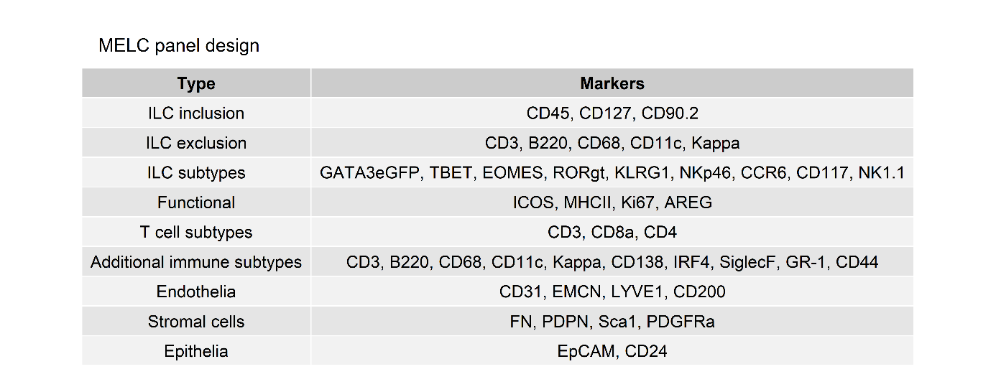

**Supplementary Table 2:** Overview of technical components of the Toponome Image Cycler Mm3 and the BioDecipher Device 1.0 used for MELC data acquisition.

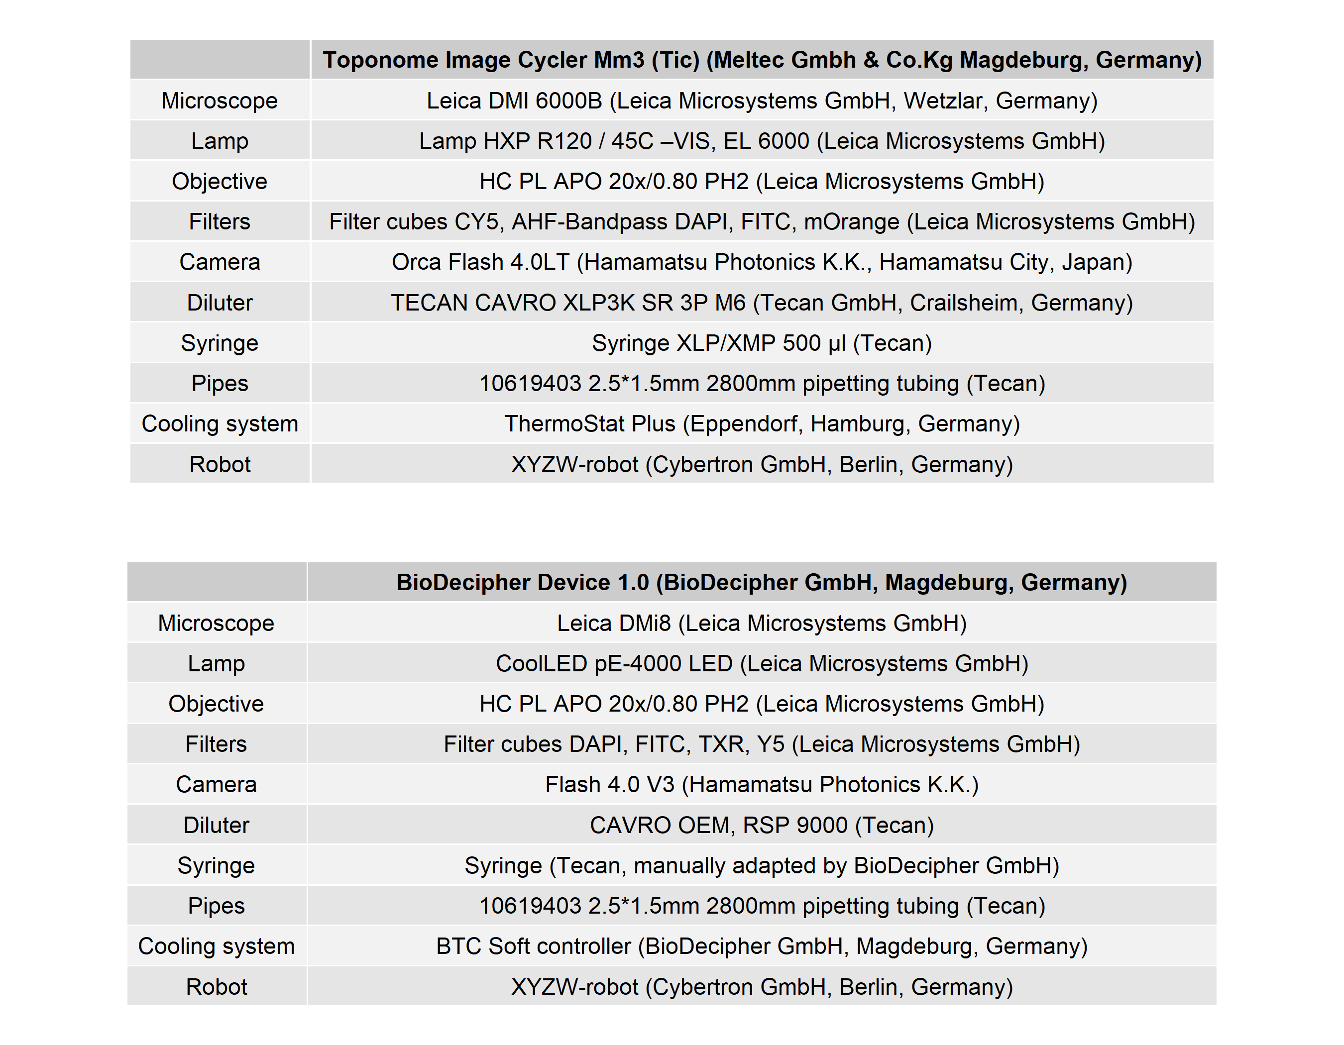

**Supplementary Table 3:** MELC antibody panel overview

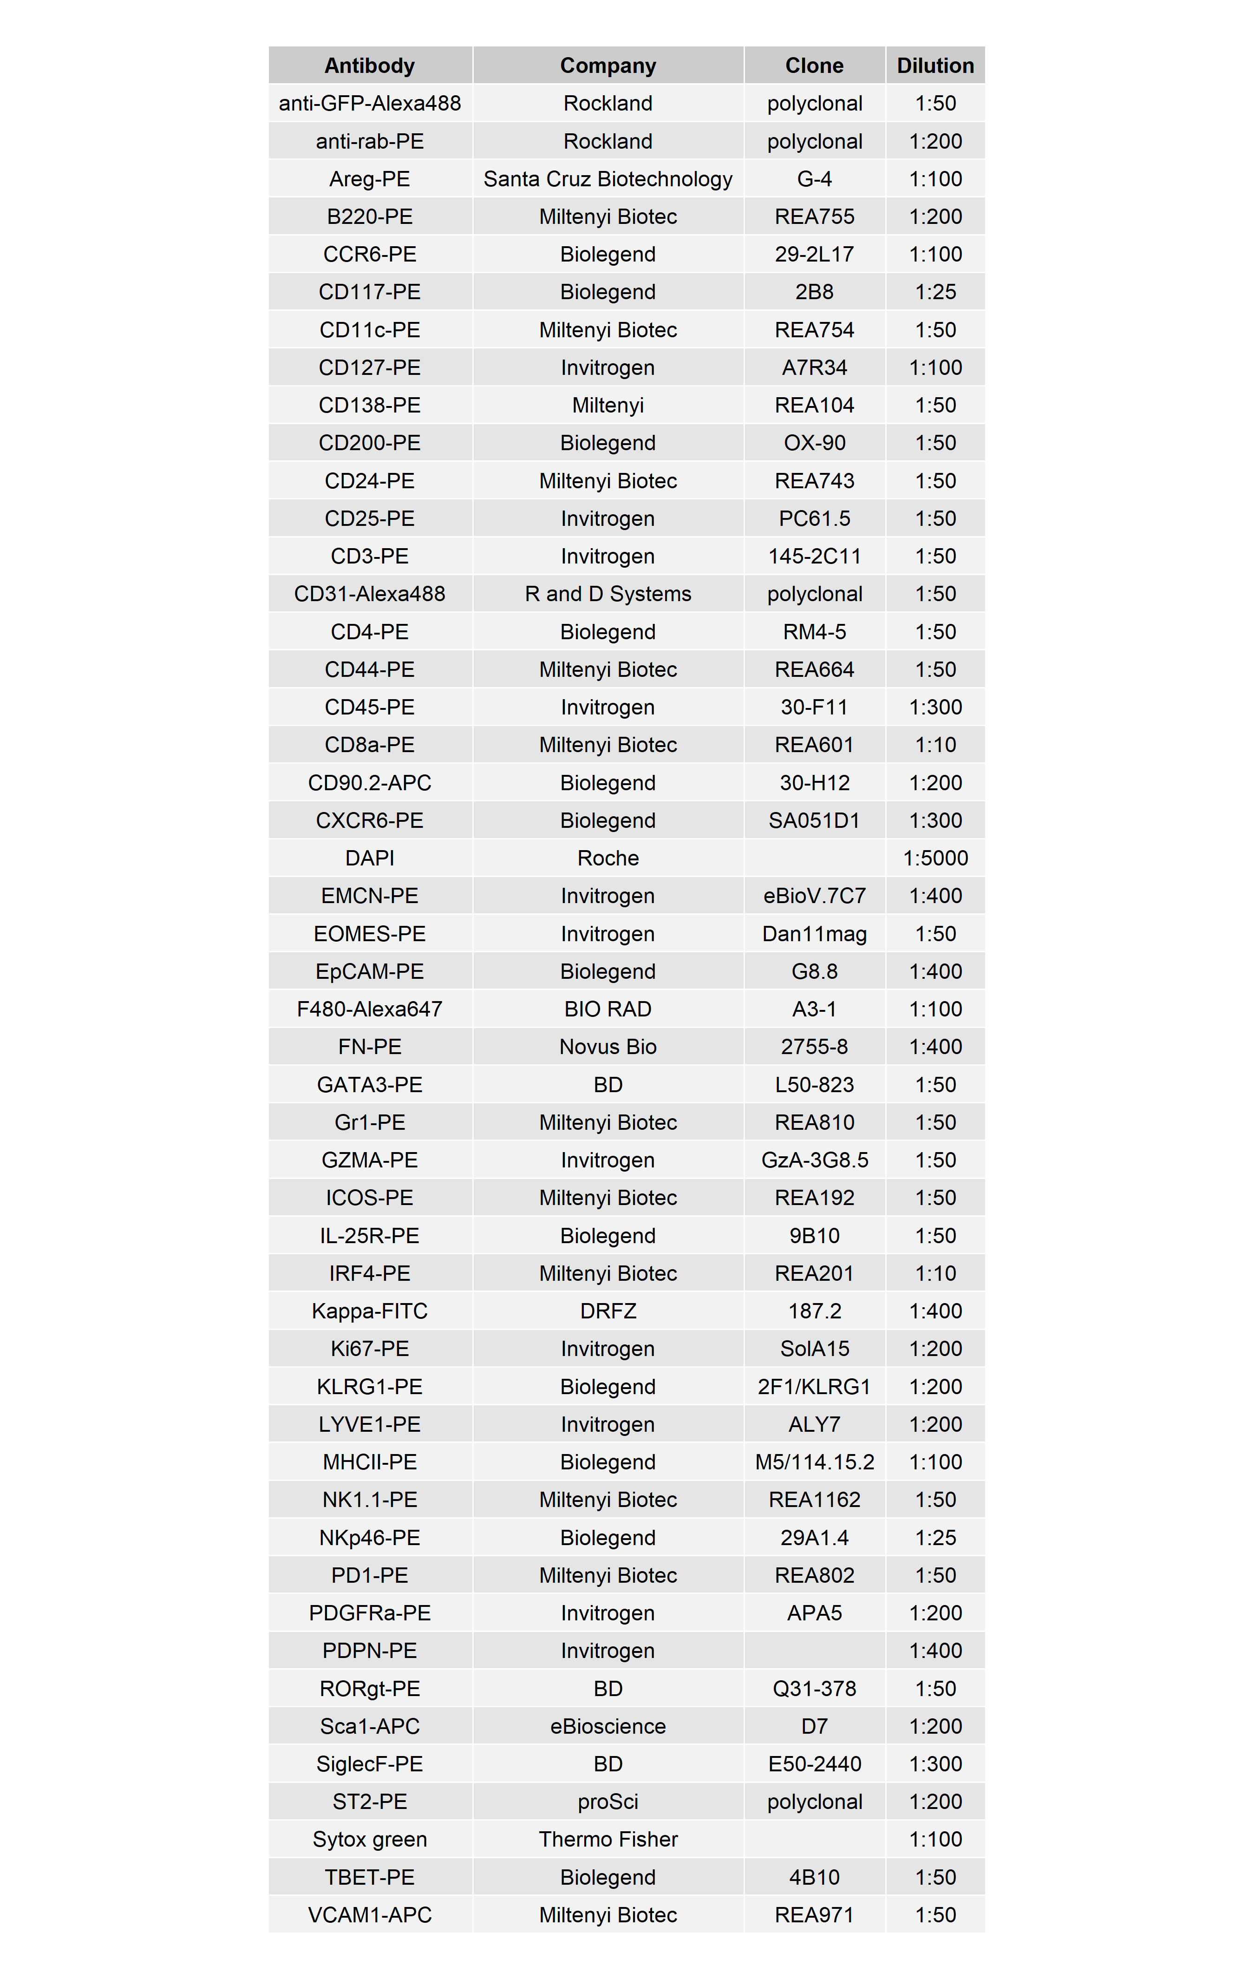

**Supplementary table 4:** Overview of R packages and versions used for data analysis.

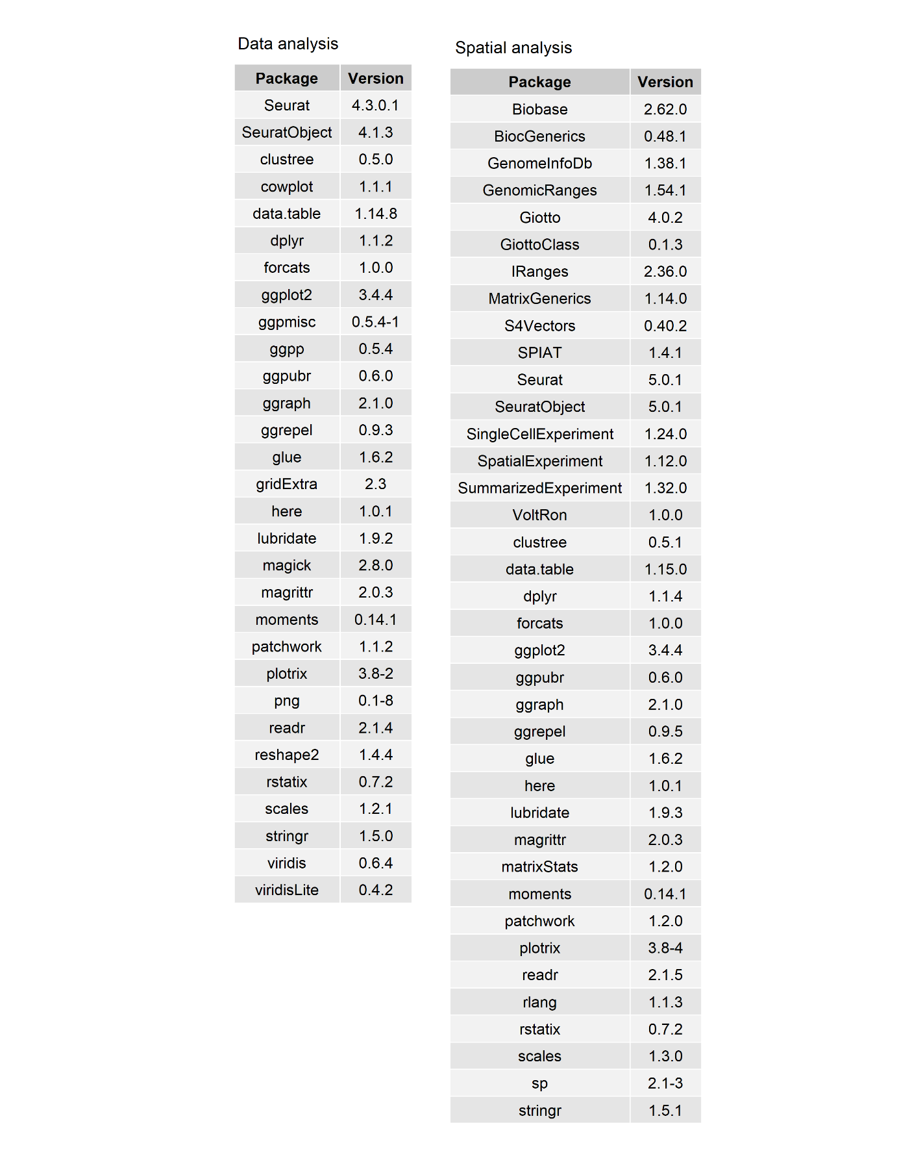

**Figures with legends**

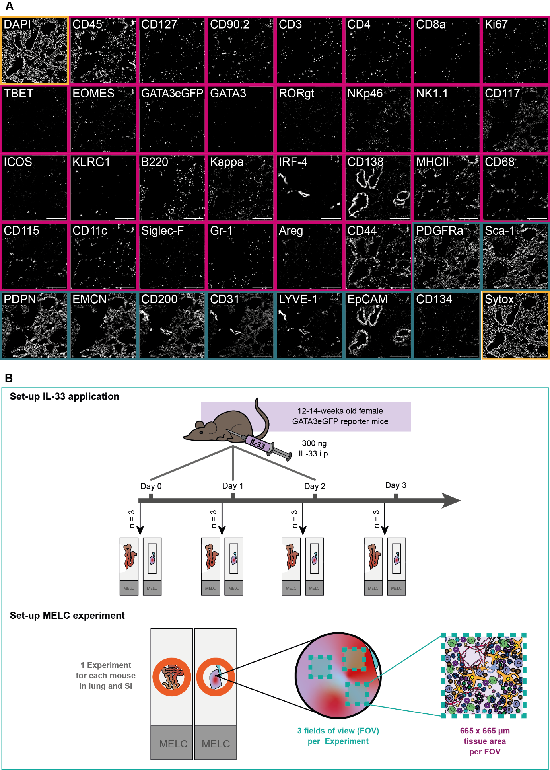

**Figure 1: (A)** Overview of an established 40-marker panel in an exemplary tissue region of murine lung. Each image shows the same tissue region stained for diverse immune markers (magenta) and structural markers (darkcyan), as well as nuclei stains (yellow). Scale bar represents 200 µm. **(B)** Schematic of the experimental set-up of the IL-33 systemic inflammation model and the MELC experiment. In short, 12-14-week-old GATA3eGFP reporter mice were i.p. injected with 300 ng IL-33 on up to 3 consecutive days. 24 h after the last dose, organs were harvested and processed for cyclic IF (MELC). In each MELC experiment, three regions of interest (fields of view = FOV) were acquired, each measuring 665 x 665 µm.

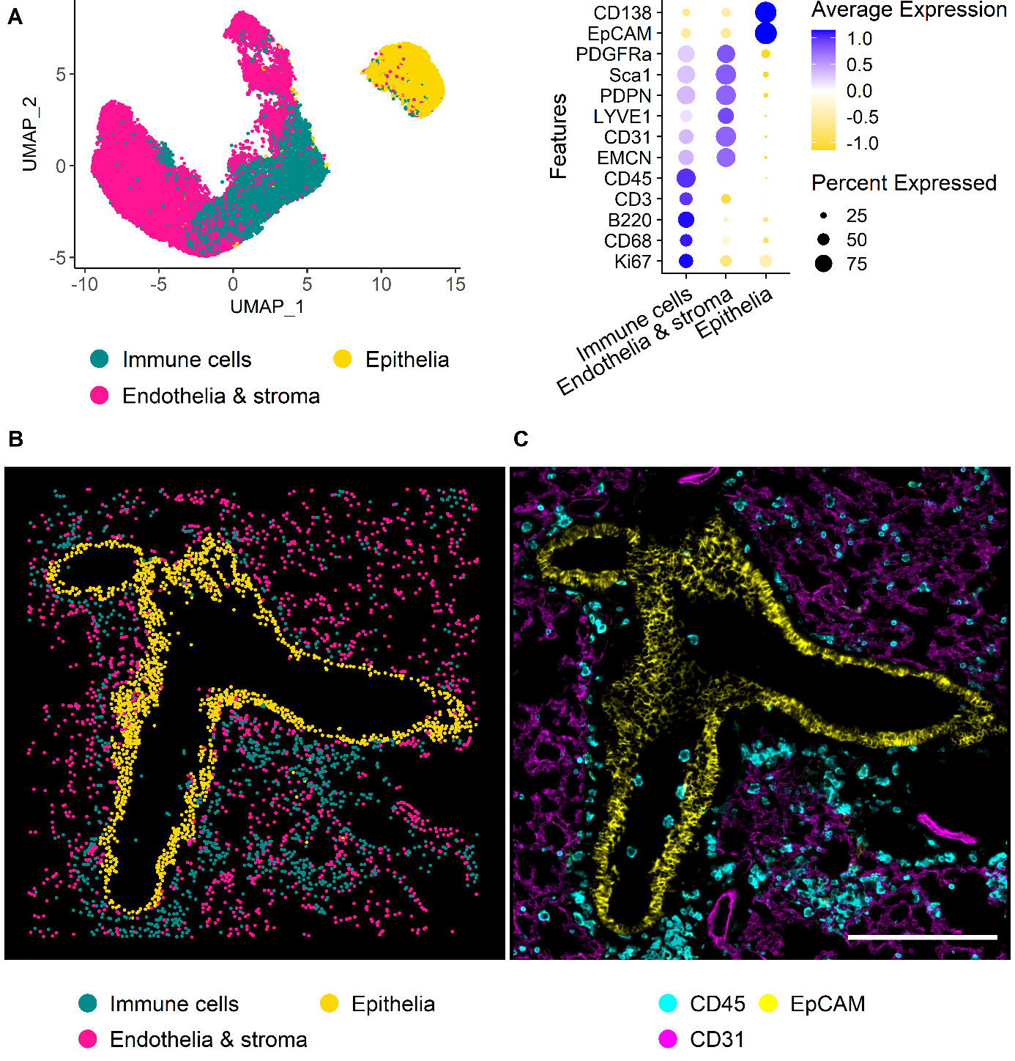

**Figure 2: (A)** UMAP representation of the first level of annotation (AL1) in murine lung tissue showing the three clusters annotated as Immune cells, endothelia & stroma, and epithelia based on the feature profiles shown in the dot plot beside. **(B)** Annotated clusters of AL1 mapped in X and Y. Annotations are colored by cell type with immune cells (Cyan), endothelia & stroma (Magenta), and epithelia (Yellow). **(C)** IF overlay of CD45 (Cyan), CD31 (Magenta), and EpCAM (Yellow) of the same FOV shown in B. Scale bar: 200 µm.

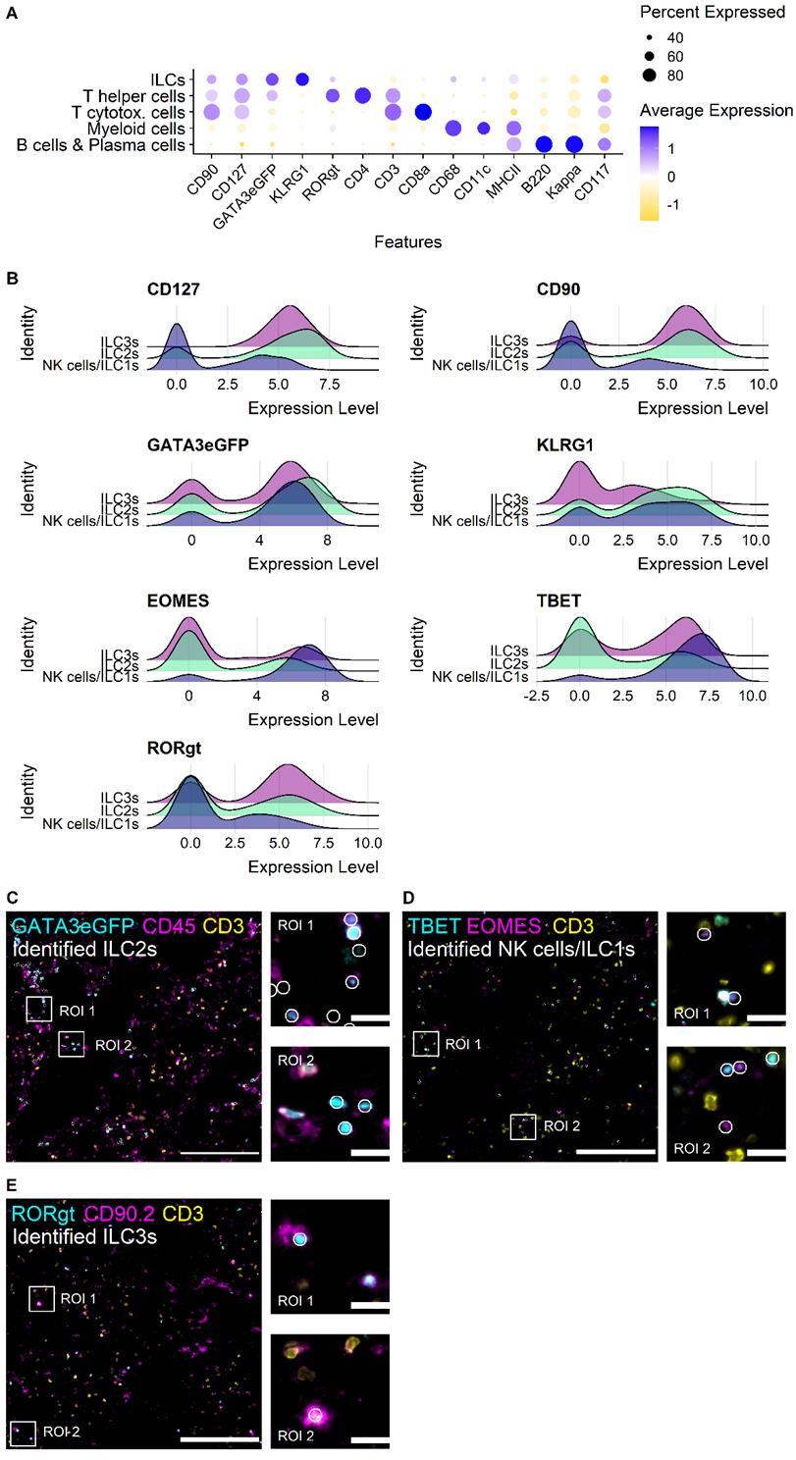

**Figure 3: (A)** Dot plot showing the marker profiles of the annotated immune cell types in murine lung data including ILCs. **(B)** Ridge plots of ILC-related markers showing the levels for the identified ILC subsets in murine lung NK cells/ILCs, ILC2s, and ILC3s. **(C)** Visual validation NK cells/ILC1s. Cells are depicted on IF overlay of TBET (Cyan), EOMES (Magenta), CD3 (Yellow). **(D)** Visual validation of ILC2s. Cells are overlayed with GATA3eGFP (Cyan), CD45 (Magenta), and CD3 (Yellow). **(E)** Visual validation of identified ILC3s. Cells annotated as ILC3s are depicted on IF overlay showing RORgt (Cyan), CD90.2 (Magenta) and CD3 (Yellow). (D-E) Identified cells are depicted as white circles, each circle representing one cell. White boxes mark regions of interest that are zoomed in respectively on the right side. Scale bars represent 200 µm in overviews, and 20 µm in ROIs.

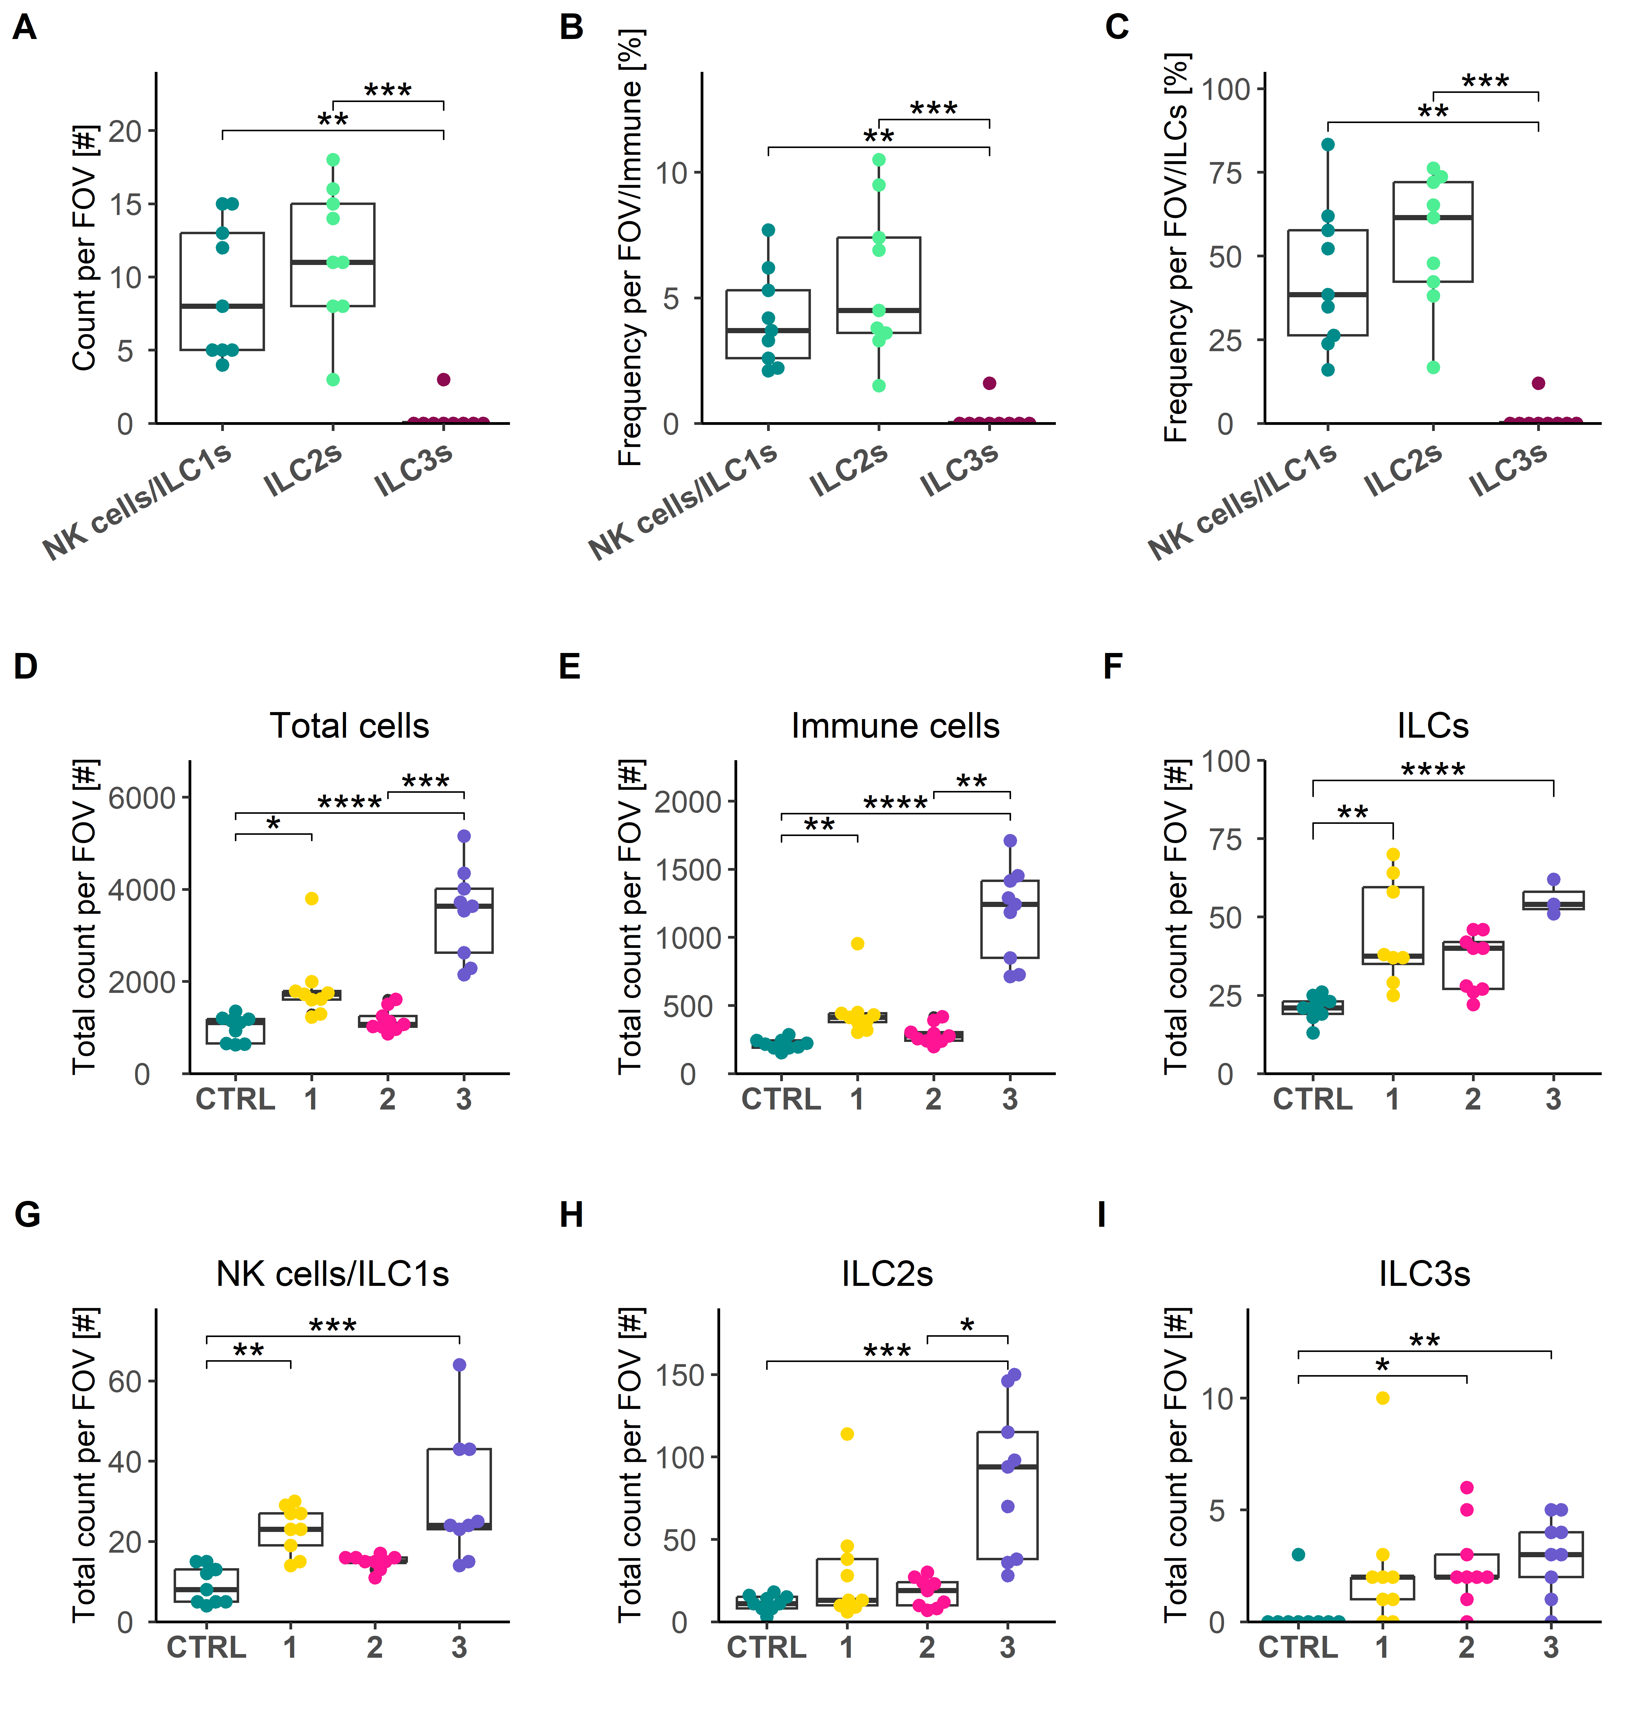

**Figure 4: (A)** Box plot depicting the total number of analyzed cells per FOV split by condition. **(B)** Box plot depicting the total number of analyzed immune cells per FOV split by condition. **(C)** Box plot depicting the total number of analyzed ILCs per FOV split by condition. **(D-F)** Box plots showing the total count of all annotated cells, immune cells, and ILCs per analyzed condition per FOV, respectively. **(G-H)** Box plots showing the total count of NK cells/ILC1s, ILC2s, and ILC3s per analyzed condition per FOV, respectively. (A-I) FOV = analyzed fields of view; n = 9; each dot represents one analyzed FOV. (A-I) For statistical analysis, Kruskal-Wallis-test was used to check for significance between tested groups and effect size, Dunn’s test was used as post-hoc test for pairwise comparison. Asterisk marks significance level.

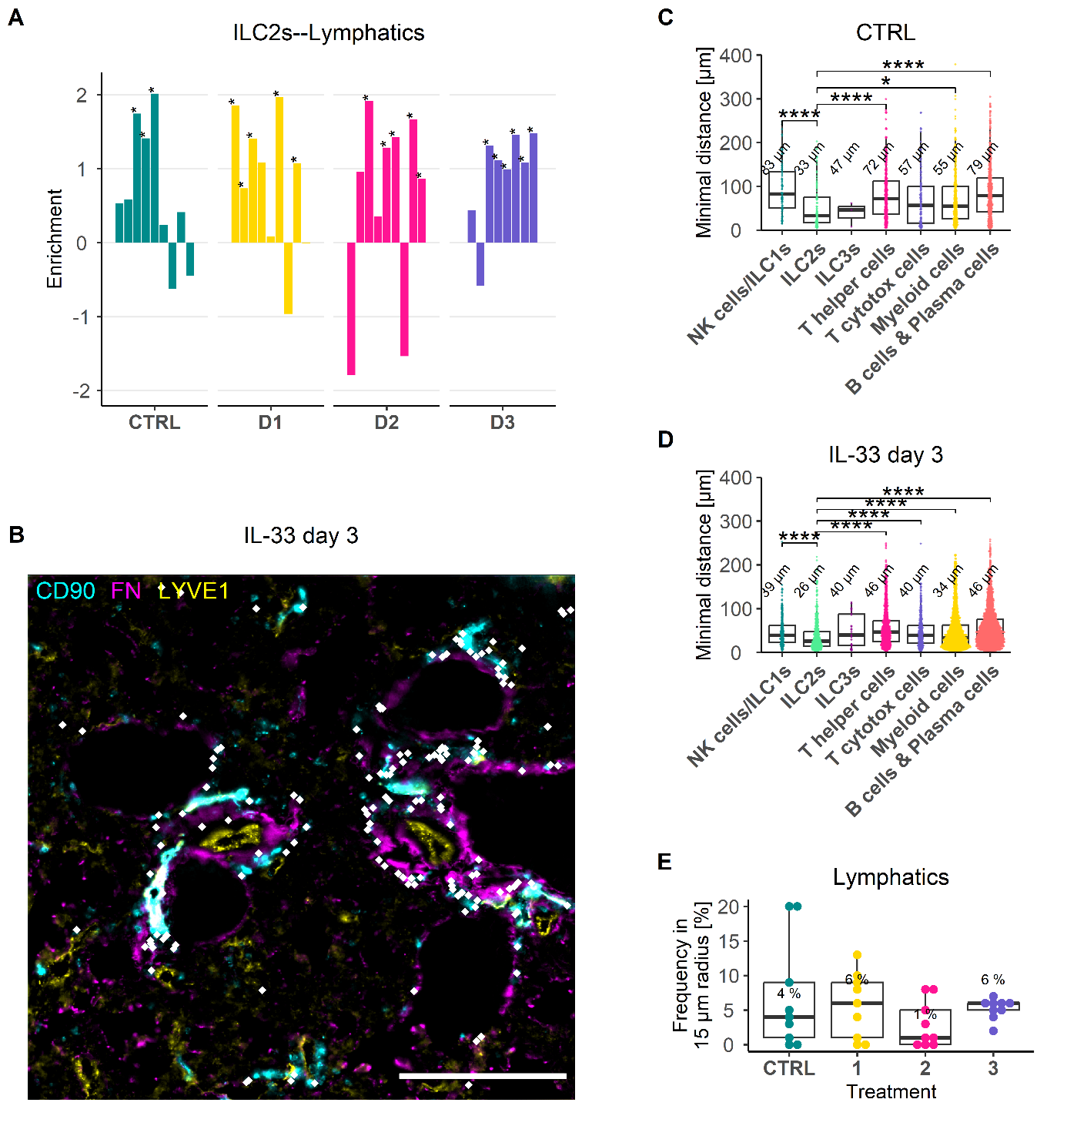

**Figure 5: (A)** Bar plot showing the results of the co-enrichment analysis of ILC2s and lymphatics. Each bar represents one analyzed FOV. Asterisks mark p-value lower than 0.05. **(B)** IF overlay of CD90.2 (Cyan), FN (Magenta) and LYVE1 (Yellow). White dots mark identified ILC2s. Each dot represents one identified cell. Scale bar: 200 µm. **(C)** Box plot depicting the minimal distances of the identified immune cell types to lymphatics as reference cells under healthy conditions. Number represents the median minimum distance for the respective cell type in µm. **(D)** Box plot depicting the minimal distances of the identified immune cell types to lymphatics as reference cells at IL-33 day 3. Number represents the median minimum distance for the respective cell type in µm. **(E)** Box plot showing the result of the CIN analysis showing the frequency of lymphatics in a 15 µm radius around ILC2s used as reference cells. Number represents the median frequency at each condition in %. (C-D) Each dot represents one cell from 9 analyzed FOVs per condition. For statistical analysis, Kruskal-Wallis-test was used to check for significance between tested groups and effect size, Dunn’s test was used as post-hoc test for pairwise comparison. Asterisk marks significance level.

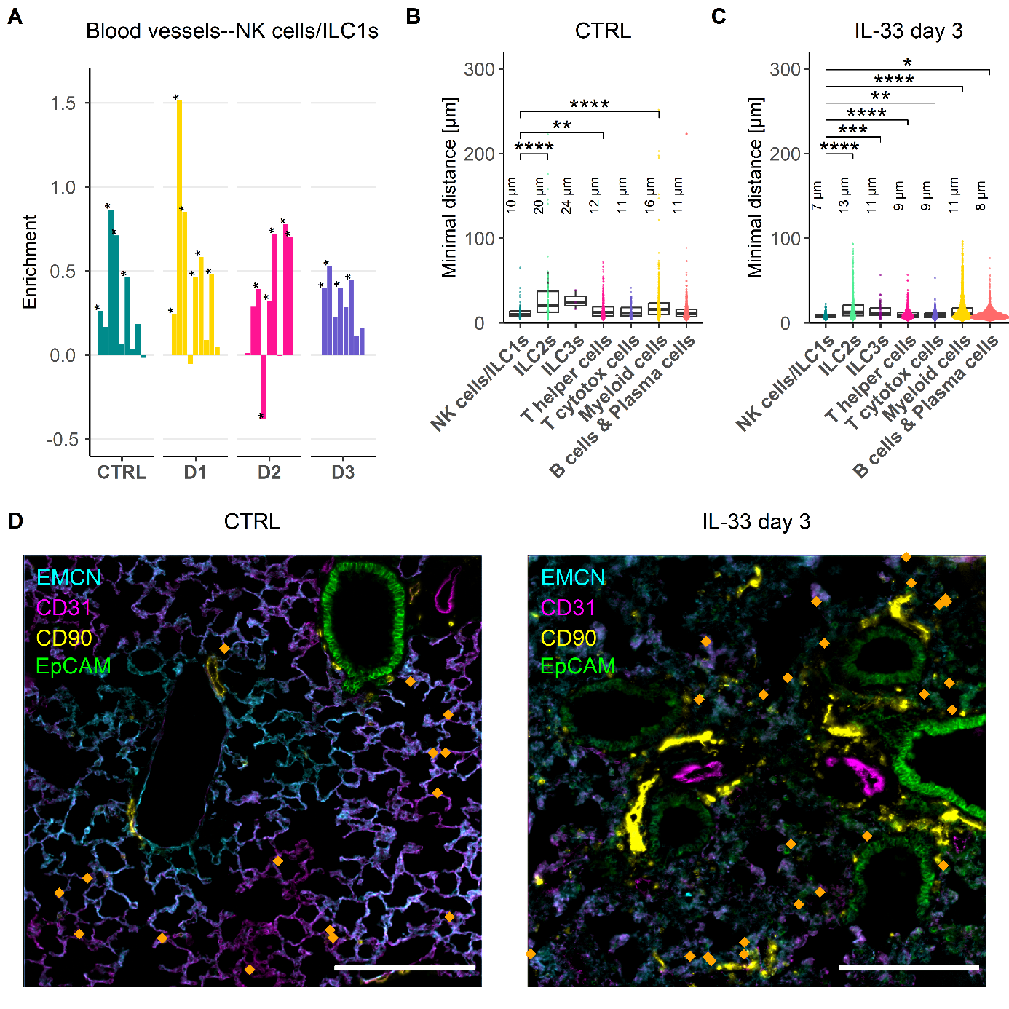

**Figure 6: (A)** Bar plot showing the results of the co-enrichment analysis of NK cells/ILC1s and blood vessels. Each bar represents one analyzed FOV. **(B)** Box plot depicting the minimal distance of identified immune cell types to blood vessels under healthy conditions in murine lungs. **(C)** Box plot depicting the minimal distance of identified immune cell types to blood vessels at IL-33 day 3 in murine lungs. **(D)** IF overlays of EMCN (Cyan), CD31 (Magenta), CD90 (Yellow), and EpCAM (Green) depicted with identified NK cells/ILC1s on top as dots (Orange) in murine lung under healthy conditions (Left) and at IL-33 day 3 (Right). Scale bar represents 200 µm. Each dot represents one identified cell. (B-C) For statistical analysis, Kruskal-Wallis-test was used to check for significance between tested groups and effect size, Dunn’s test was used as post-hoc test for pairwise comparison. Asterisk marks significance level.

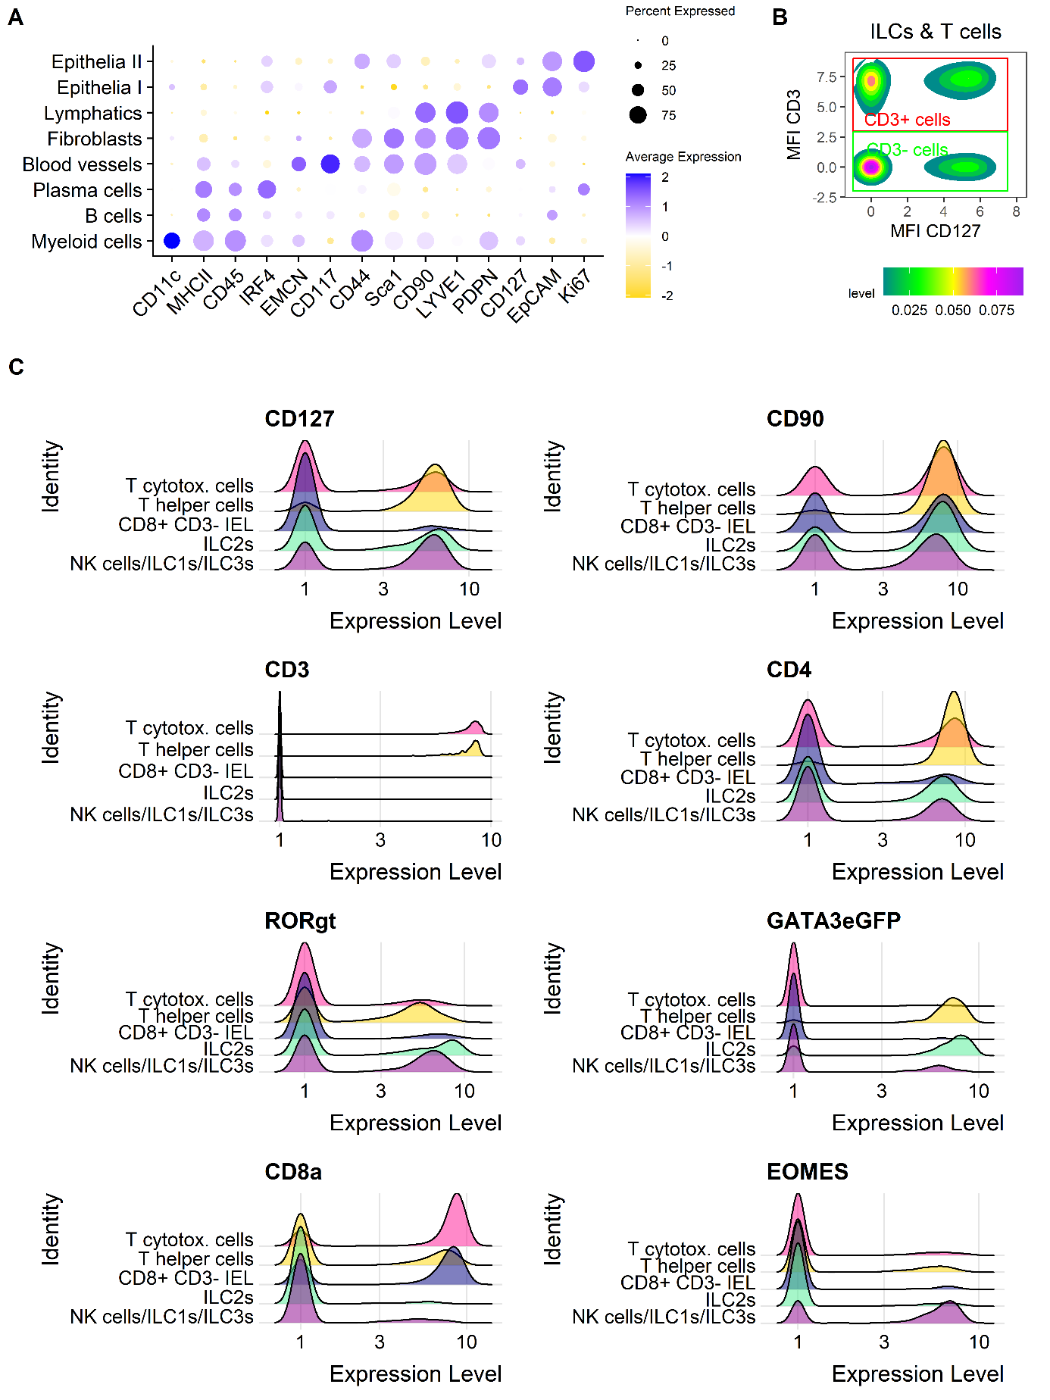

**Figure 7: (A)** Dot plot of AL2 showing feature profiles of identified immune and non-immune cell types. **(B)** Density plot showing the thresholding strategy for the subsequent analysis of CD3+ and CD3- cells. **(C)** Ridge plots comparing the feature profiles of identified ILC, NK cell, and T cell subtypes.

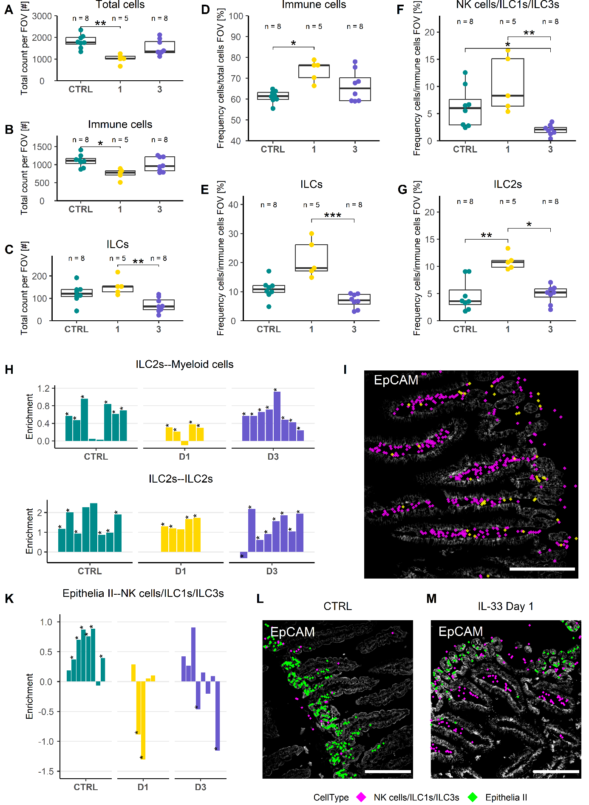

**Figure 8: (A-C)** Boxplots quantifying the total cells, immune cells, and ILCs in analyzed FOV of SI villi regions. **(D)** Boxplot showing the frequency of the immune cells compared to all identified cells of the analyzed FOVs in SI villi regions. **(E-G)** Boxplots depicting the frequency of ILCs, NK cells/ILC1s/ILC3s, and ILC2s within the immune compartment in all analyzed FOVs of SI villi regions. **(H)** Bar plots showing the results of the co-enrichment analysis of ILC2s and myeloid cells, as well as ILC2s and ILC2s in SI villi tissue regions. **(I)** IF staining of EpCAM (White) in a representative FOV of SI villi superimposed with identified ILCs (Yellow dots) and myeloid cells (Magenta dots). **(K)** Results of the co-enrichment analysis of NK cells/ILC1s/ILC3s and epithelia II cells at different analyzed conditions shown in a bar plot. **(L-M)** IF staining of EpCAM (White) shown in a representative SI villi FOV together with identified NK cells/ILC1s/ILC3s (Magenta) and epithelia II cells (Green). (A-G) FOV = analyzed fields of view; N represents the number of analyzed FOVs, each dot represents one analyzed FOV. For statistical analysis, Kruskal-Wallis-test was used to check for significance between tested groups and effect size, Dunn’s test was used as post-hoc test for pairwise comparison. Asterisk marks significance level.

**Supporting information**

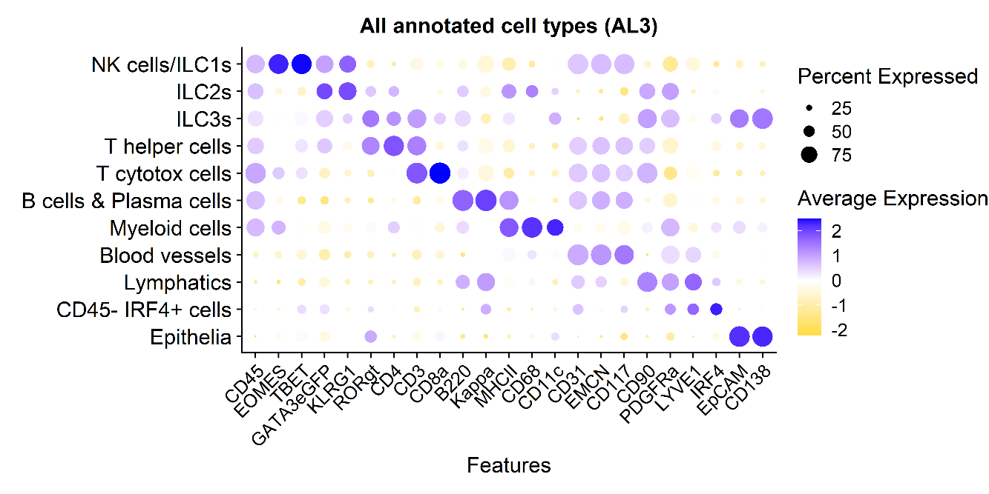

**Supplementary Fig. 1:** Dot plot showing the feature profile of all annotated cell types including immune and non-immune cells in the analyzed murine lung data.

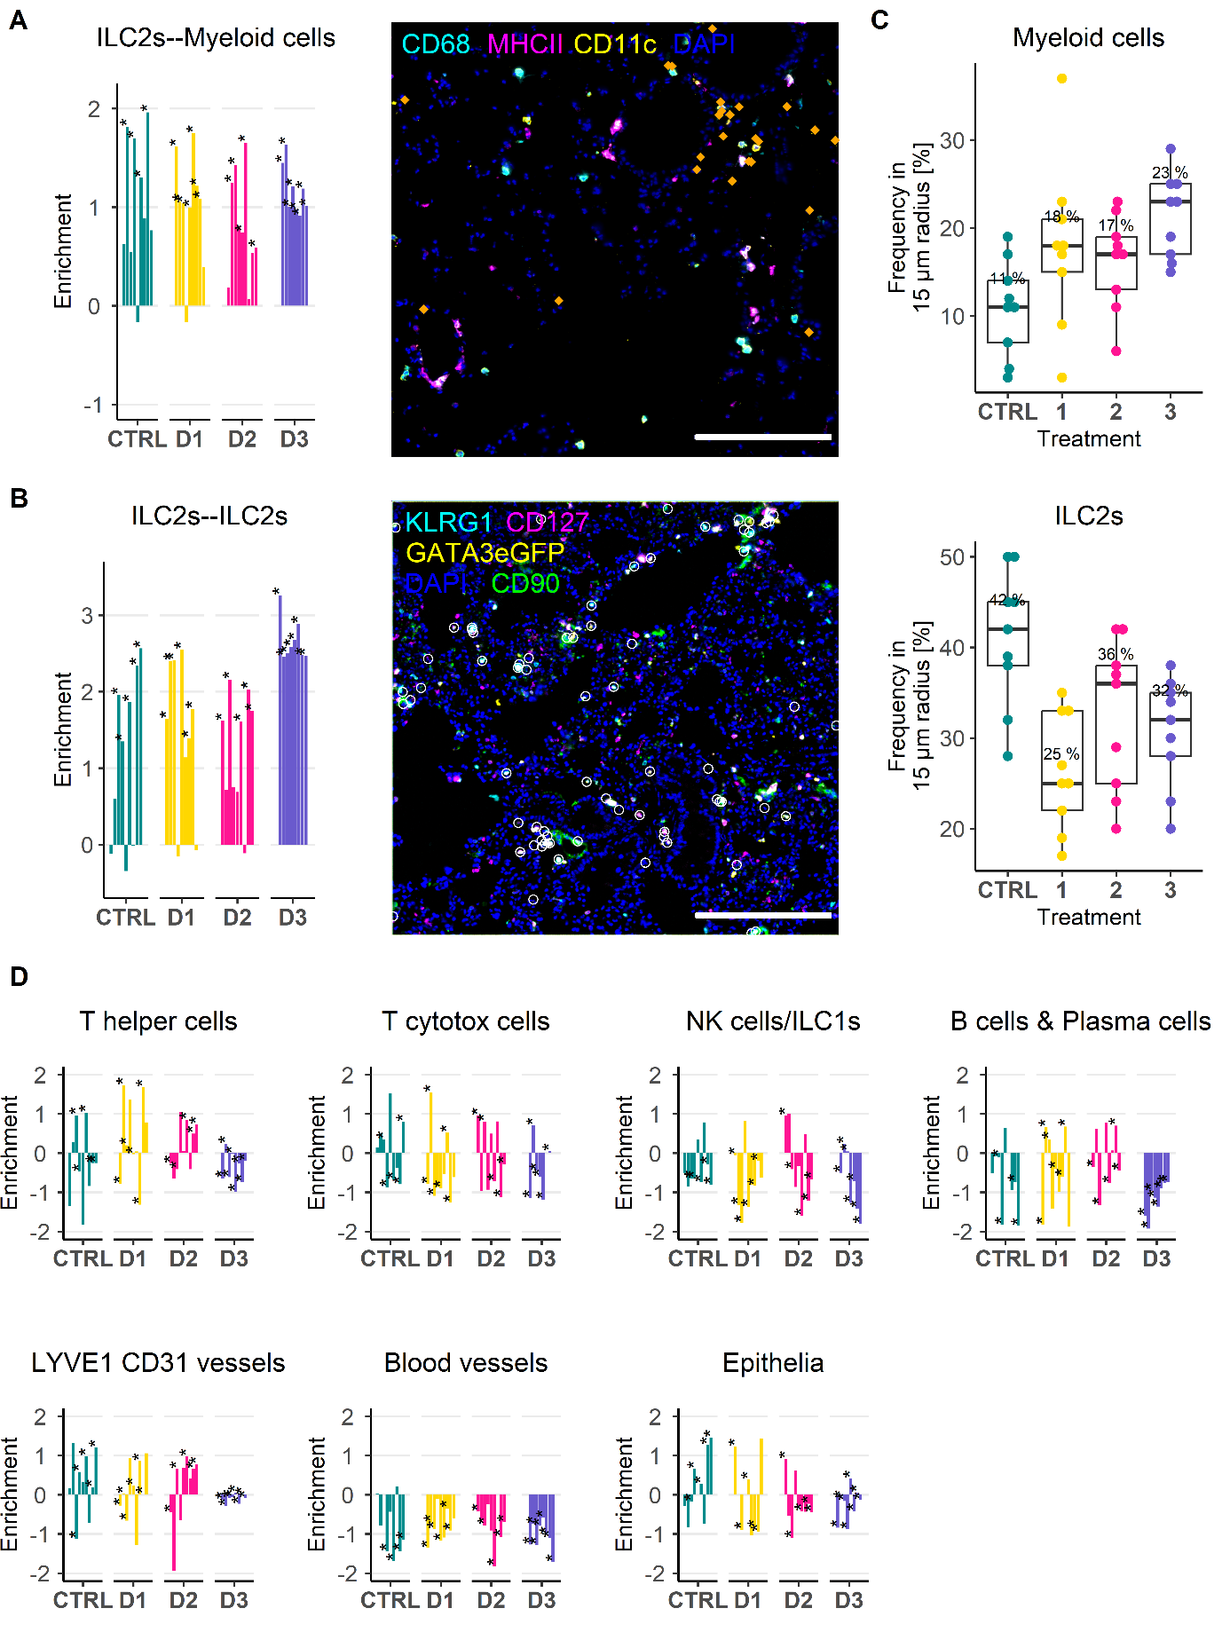

**Supplementary Fig. 2: (A)** Bar plot showing the results of the co-enrichment analysis of ILC2s and myeloid cells. Each bar represents one analyzed FOV. IF overlay stained for CD68 (Cyan), MHC II (Magenta), CD11c (Yellow), and DAPI (Blue), and with identified ILC2s depicted as dots (Orange). Scale bar represents 200 µm. Each dot represents one identified ILC2. **(B)** Bar plot showing the results of the co-enrichment analysis of ILC2s and ILC2s. **(C)** Box plot depicting the results of the CIN analysis of ILC2s of myeloid cells (upper) and ILC2s (lower). **(D)** Overview of the results of the co-enrichment analysis of ILC2s with other identified immune and non-immune cells.

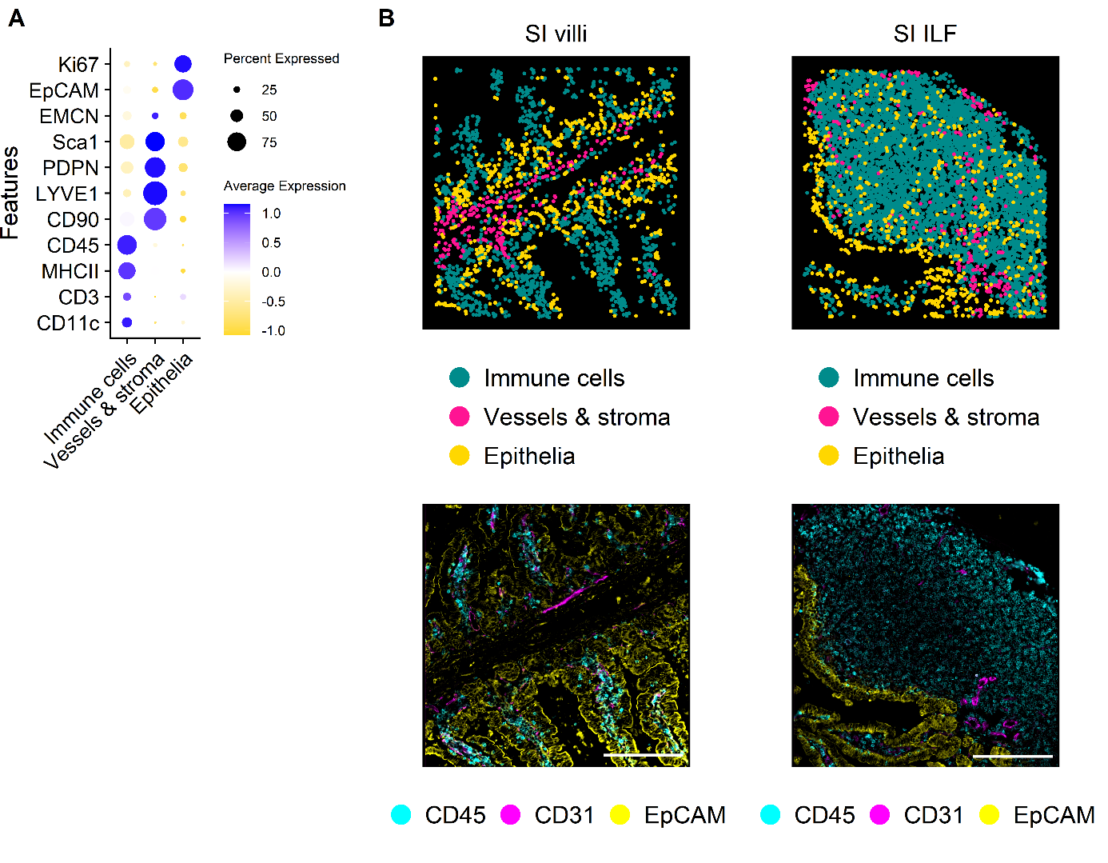

**Supplementary Fig. 3: (A)** Dot plot showing the feature profiles of the annotated major cell types of AL1 in murine SI tissue. **(B)** Visual validation of annotated cell types (Upper panel) and the respective IF overlays (Lower panel) in a representative FOV of SI villi (Left) and SI ILF (Right) tissue area. Depicted identified cell types are immune cells (Darkcyan), vessels & stroma (Pink) and epithelia (Gold). Overlay shows stainings of CD45 (Cyan), CD31 (Magenta), and EpCAM (Yellow). Scale bar represents 200 µm.

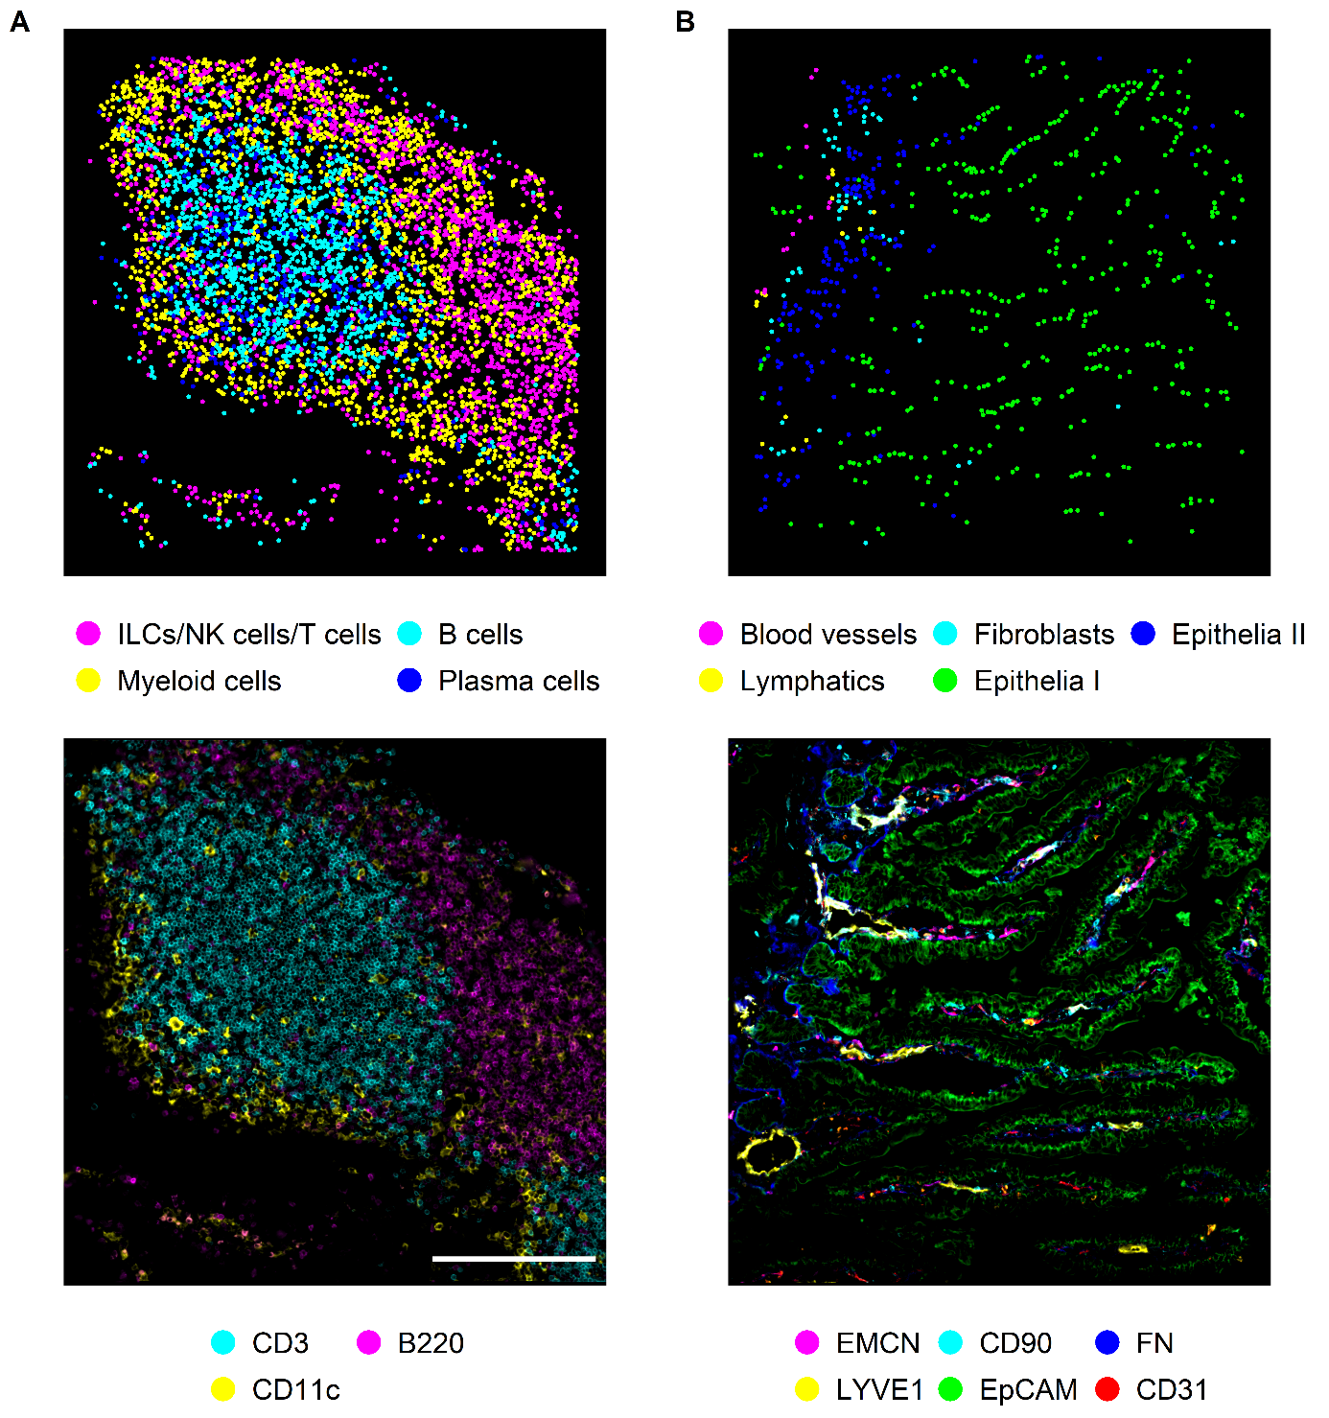

**Supplementary Fig. 4: (A)** Spatial plot of identified immune cell types of one representative FOV of murine SI and the respective IF overlay showing B220 (Cyan), CD3 (Magenta), and CD11c (Yellow). **(B)** Spatial plot of identified immune cell types of one representative FOV of murine SI and the respective IF overlay. Identified and depicted cell types are blood vessels (Magenta), fibroblasts (Cyan), lymphatics (Yellow), epithelia I cells (Green), and epithelia II cells (Blue). IF stainings overlayed are CD90.2 (Cyan), EMCN (Magenta), FN (Blue), EpCAM (Green), CD31 (Red), and LYVE1 (Yellow). Scale bar represents 200 µm.

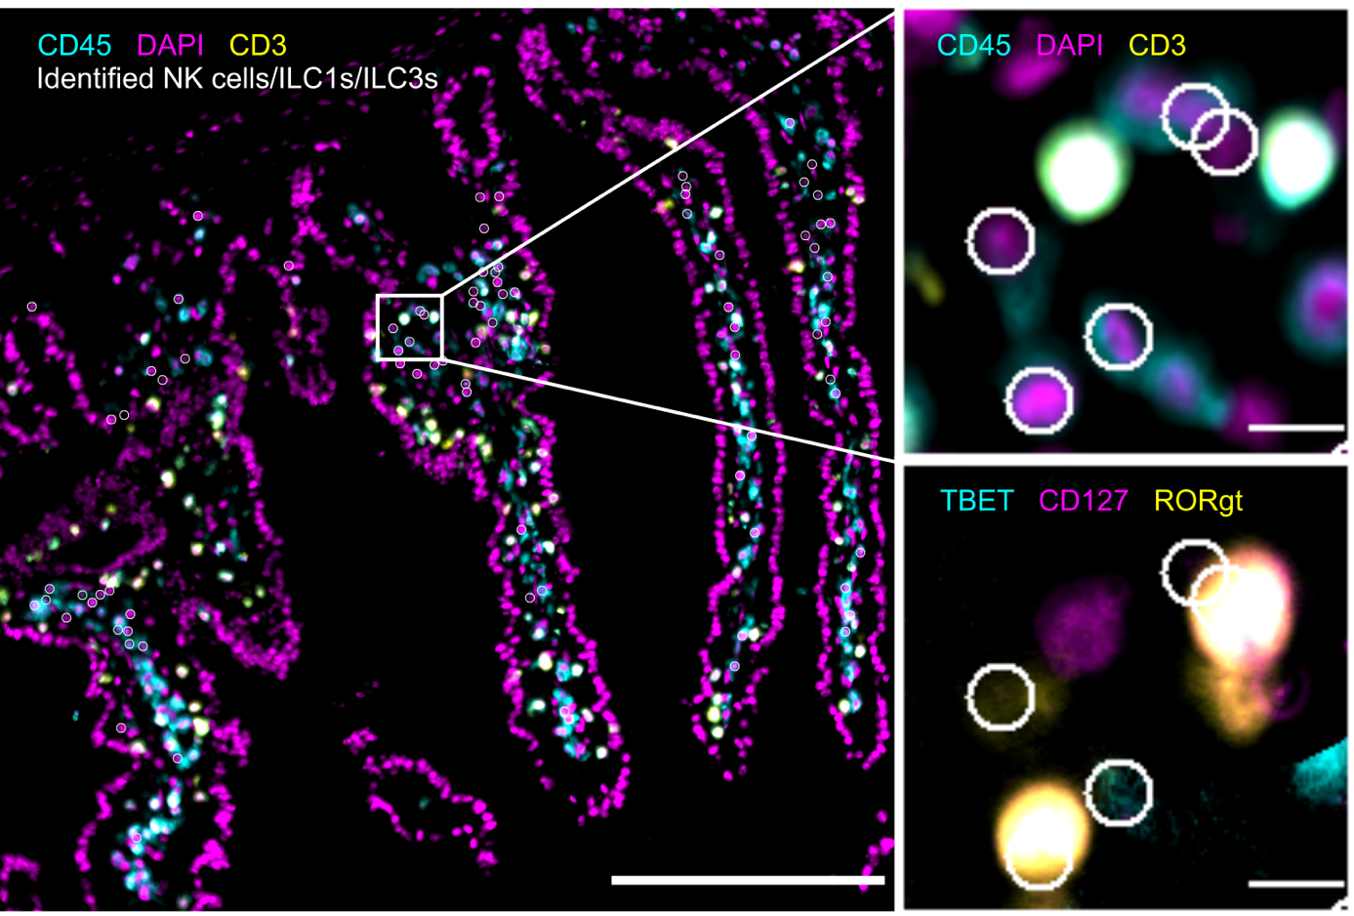**Supplementary Fig. 5:** Visual validation of the annotated NK cell/ILC1/ILC3 cluster in a representative FOV of SI villi. Identified NK cells/ILC1s/ILC3s (White circles) are depicted on corresponding IF overlay of CD45 (Cyan), DAPI (Magenta), and CD3 (Yellow) in a representative tissue area of SI villi. White box represents ROI that shown in detail with the same marker combination in the upper right square. Additionally, an IF overlay of TBET (Cyan), CD127 (Magenta), and RORγt (Yellow) with identified NK cells/ILC1s/ILC3s (White circles) on top is shown for the ROI in the lower left square. Each white circle represents one cell. Scale bar: 200 µm in overview image; 10 µm in ROIs. FOV = field of view; ROI = region of interest; IF = immunofluorescence.

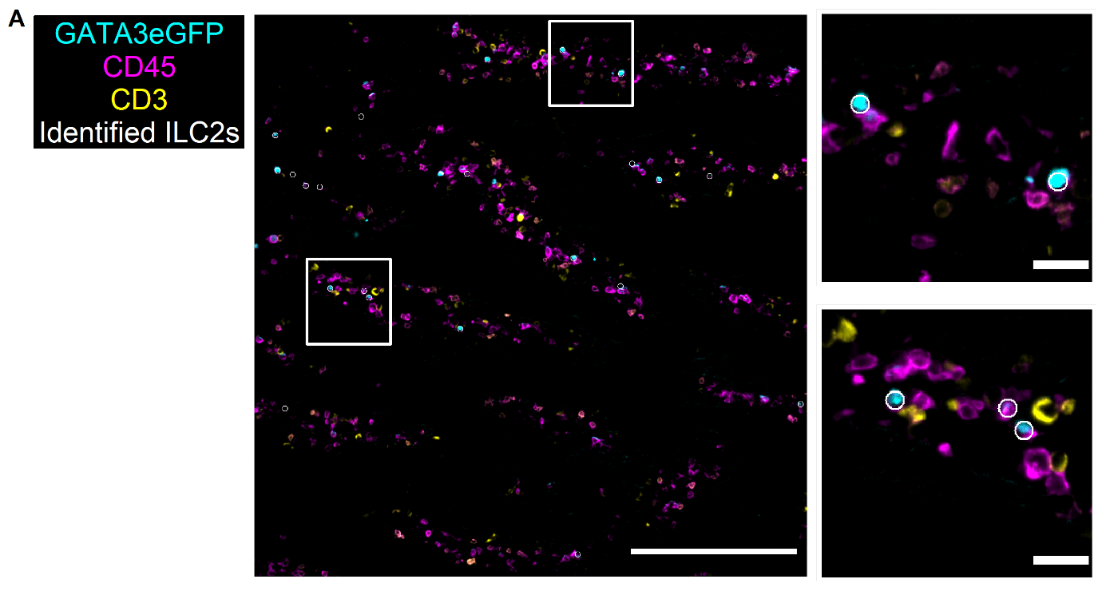

**Supplementary Fig. 6:** Visual validation of annotated ILC2 cluster in SI villi region. Cells identified and annotated as ILC2s (White circles) are depicted on the respective IF stainings for GATA3eGFP (Cyan), CD3 (Yellow), CD45 (Magenta) in an exemplary FOV covering SI villi structures. White boxes show regions of interest (ROI) that are enlarged in the right side. Each white circle represents one cell. Scale bar: 200 µm in overview; 20 µm in ROIs. FOV = field of view; ROI = region of interest; IF = immunofluorescence.

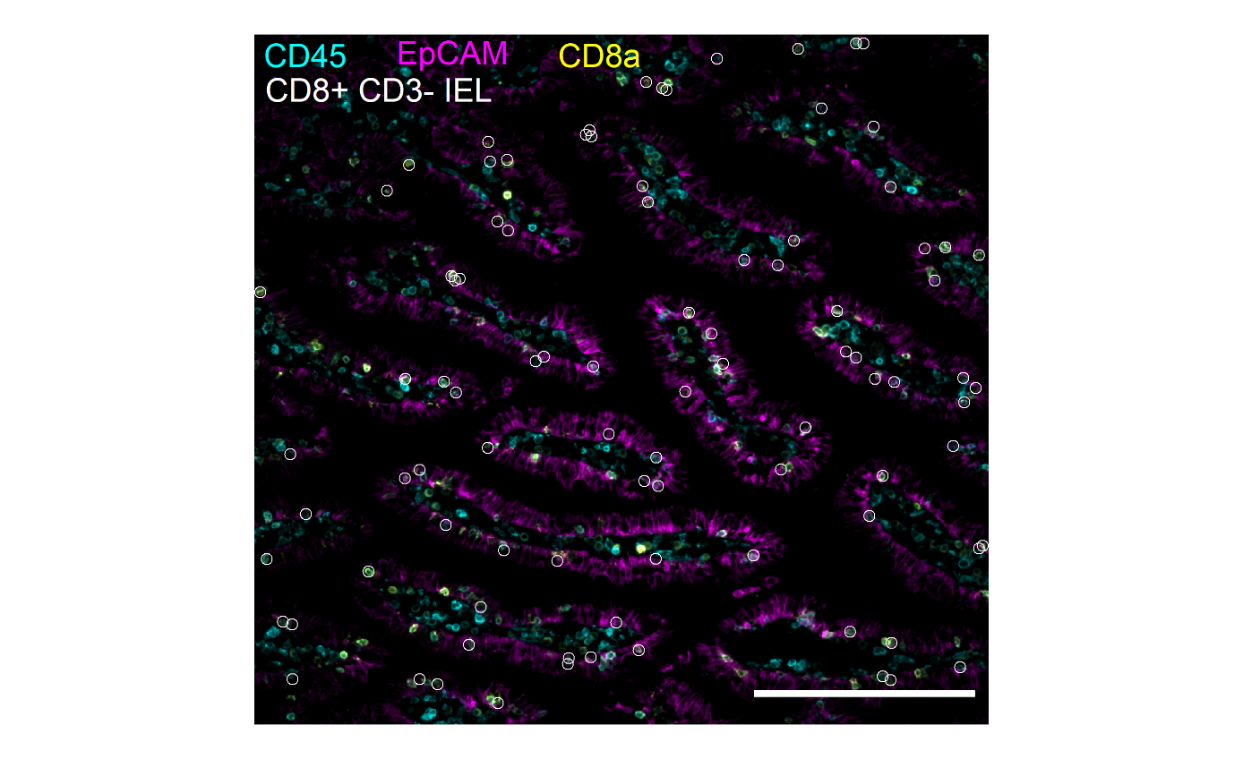

**Supplementary Fig. 7:** IF overlay showing cells of the CD8+ CD3- IEL cluster in a representative FOV in SI villi. CD45 (Cyan), EpCAM (Magenta), and CD8a (Yellow) are overlayed and depicted on top are identified CD8+ CD3- IEL (White circles). Each white circle represents one CD8+ CD3- IEL. Scale bar represents 200 µm.

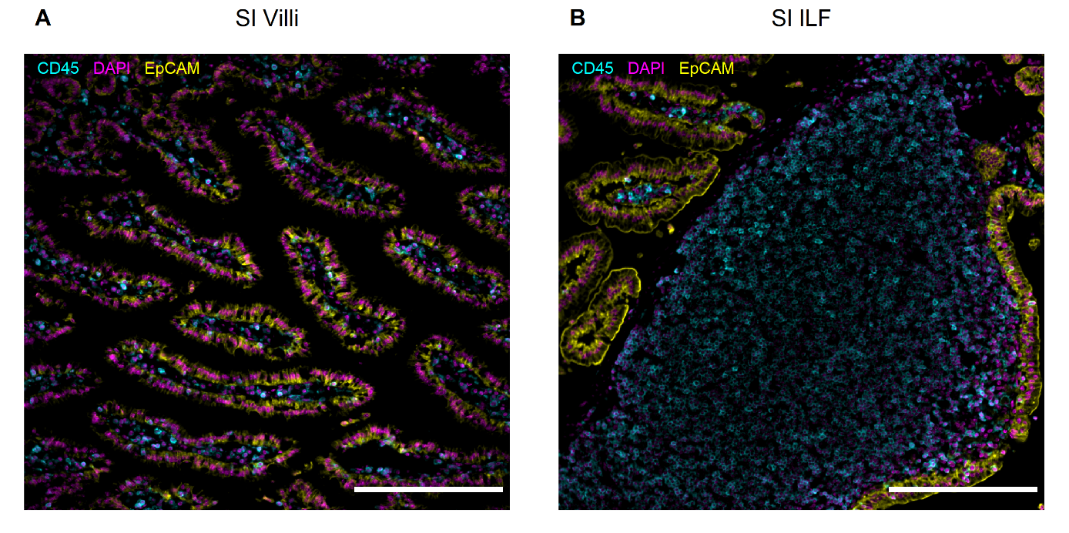

**Supplementary Fig. 8: (A)** IF overlay showing a representative FOV in SI villi stained with CD45 (Cyan), EpCAM (Yellow), and DAPI (Magenta). **(B)** IF overlay showing a representative FOV in SI ILF stained with CD45 (Cyan), EpCAM (Yellow), and DAPI (Magenta). Scale bar represents 200 µm. IF = immunofluorescence; FOV = field of view; ILF = intestinal lymphoid follicle; SI = small intestine.

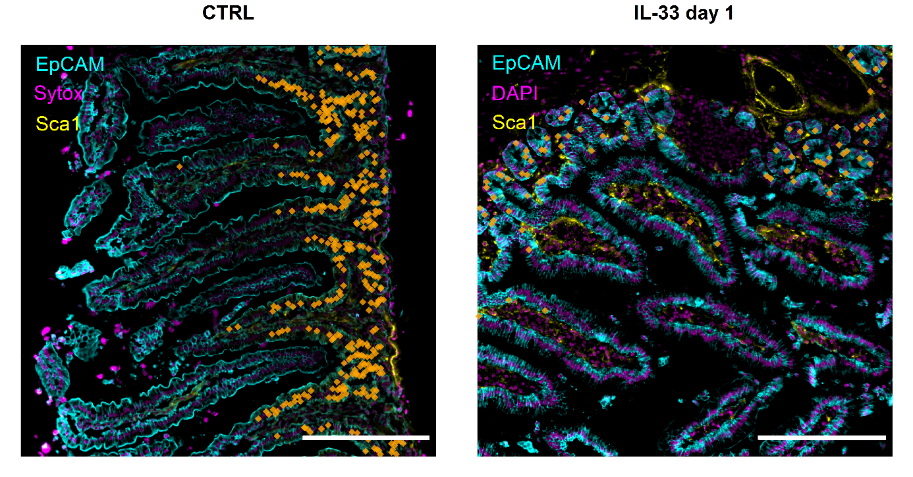

**Supplementary Figure 9:** A representative FOV of healthy SI villi and day 3 after IL-33 application showing theIF overlay of EpCAM (Cyan), DAPI (Magenta), and Sca1 (Yellow). Cells of the epithelia II cluster are superimposed (Orange dots) on the IF overlay. Each dot represents one annotated cell. Scale bar represents 200 µm. FOV = field of view.

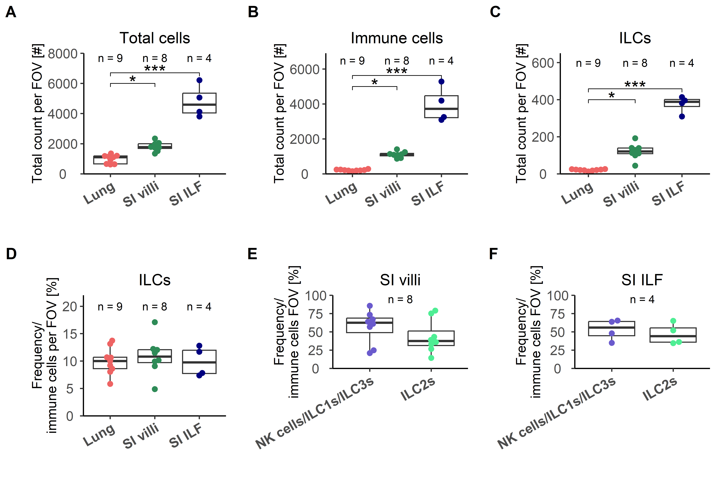

**Supplementary Figure 10: (A-C)** Boxplots showing the total count of cells per analyzed FOV for all cells, immune cells and ILCs for the analyzed organs and tissue types, namely lung, SI villi, and SI ILF. **(D)** Boxplots depicting the frequency of ILCs within the immune compartment for the analyzed organs and tissue types, namely lung, SI villi, and SI ILF. **(E-F)** Boxplots showing the total cell count of NK cells/ILC1s/ILC3s and ILC2s per analyzed FOV in murine SI villi regions. N = number of analyzed FOV.

**REFERENCES**

Vancouver reference style

Literature Cited

1. Panda SK, Colonna M. Innate Lymphoid Cells in Mucosal Immunity. Front Immunol 2019; 10:861.

2. Ebbo M, Crinier A, Vély F, Vivier E. Innate lymphoid cells: major players in inflammatory diseases. Nat Rev Immunol 2017; 17(11):665–78.

3. Castellanos JG, Longman RS. The balance of power: innate lymphoid cells in tissue inflammation and repair. J Clin Invest 2019; 129(7):2640–50.

4. Vivier E, Artis D, Colonna M, Diefenbach A, Di Santo JP, Eberl G et al. Innate Lymphoid Cells: 10 Years On. Cell 2018; 174(5):1054–66.

5. Seo G-Y, Giles DA, Kronenberg M. The role of innate lymphoid cells in response to microbes at mucosal surfaces. Mucosal Immunol 2020; 13(3):399–412.

6. Sepahi A, Liu Q, Friesen L, Kim CH. Dietary fiber metabolites regulate innate lymphoid cell responses. Mucosal Immunol 2021; 14(2):317–30.

7. Shi Z, Ohno H, Satoh-Takayama N. Dietary Derived Micronutrients Modulate Immune Responses Through Innate Lymphoid Cells. Front Immunol 2021; 12:670632.

8. Chen W, Shu Q, Fan J. Neural Regulation of Interactions Between Group 2 Innate Lymphoid Cells and Pulmonary Immune Cells. Front Immunol 2020; 11:576929.

9. Šestan M, Raposo B, Rendas M, Brea D, Pirzgalska R, Rasteiro A et al. Neuronal-ILC2 interactions regulate pancreatic glucagon and glucose homeostasis. Science 2025; 387(6731):eadi3624.

10. Álvarez-Carrasco P, Maldonado-Bernal C. The innate defenders: a review of natural killer cell immunotherapies in cancer. Front Immunol 2024; 15:1482807.

11. Chen S, Zhu H, Jounaidi Y. Comprehensive snapshots of natural killer cells functions, signaling, molecular mechanisms and clinical utilization. Signal Transduct Target Ther 2024; 9(1):302.

12. Mujal AM, Delconte RB, Sun JC. Natural Killer Cells: From Innate to Adaptive Features. Annu Rev Immunol 2021; 39:417–47.

13. Herbert DR, Douglas B, Zullo K. Group 2 Innate Lymphoid Cells (ILC2): Type 2 Immunity and Helminth Immunity. Int J Mol Sci 2019; 20(9).

14. Matsuyama T, Machida K, Mizuno K, Matsuyama H, Dotake Y, Shinmura M et al. The Functional Role of Group 2 Innate Lymphoid Cells in Asthma. Biomolecules 2023; 13(6).

15. Zheng H, Zhang Y, Pan J, Liu N, Qin Y, Qiu L et al. The Role of Type 2 Innate Lymphoid Cells in Allergic Diseases. Front Immunol 2021; 12:586078.

16. Sorkhdini P, Klubock-Shukla K, Sheth S, Yang D, Yang AX, Norbrun C et al. Type 2 innate immunity promotes the development of pulmonary fibrosis in Hermansky-Pudlak syndrome. JCI Insight 2024; 9(22).

17. Hams E, Armstrong ME, Barlow JL, Saunders SP, Schwartz C, Cooke G et al. IL-25 and type 2 innate lymphoid cells induce pulmonary fibrosis. Proc Natl Acad Sci U S A 2014; 111(1):367–72.

18. Serafini N, Di Santo JP. Group 3 innate lymphoid cells: A trained Gutkeeper. Immunol Rev 2024; 323(1):126–37.

19. van de Pavert SA. Lymphoid Tissue inducer (LTi) cell ontogeny and functioning in embryo and adult. Biomed J 2021; 44(2):123–32.

20. Strober W. The LTi cell, an immunologic chameleon. Immunity 2010; 33(5):650–2.

21. Mebius RE. Organogenesis of lymphoid tissues. Nat Rev Immunol 2003; 3(4):292–303.

22. Eberl G, Marmon S, Sunshine M-J, Rennert PD, Choi Y, Littman DR. An essential function for the nuclear receptor RORgamma(t) in the generation of fetal lymphoid tissue inducer cells. Nat Immunol 2004; 5(1):64–73.

23. Bal SM, Golebski K, Spits H. Plasticity of innate lymphoid cell subsets. Nat Rev Immunol 2020; 20(9):552–65.

24. Korchagina AA, Koroleva E, Tumanov AV. Innate Lymphoid Cell Plasticity in Mucosal Infections. Microorganisms 2023; 11(2).

25. Krzywinska E, Sobecki M, Nagarajan S, Zacharjasz J, Tambuwala MM, Pelletier A et al. The transcription factor HIF-1α mediates plasticity of NKp46+ innate lymphoid cells in the gut. J Exp Med 2022; 219(2).

26. Kabil A, Shin SB, Hughes MR, McNagny KM. "Just one word, plastic!": Controversies and caveats in innate lymphoid cell plasticity. Front Immunol 2022; 13:946905.

27. Silver JS, Kearley J, Copenhaver AM, Sanden C, Mori M, Yu L et al. Inflammatory triggers associated with exacerbations of COPD orchestrate plasticity of group 2 innate lymphoid cells in the lungs. Nat Immunol 2016; 17(6):626–35.

28. Pascual-Reguant A, Köhler R, Mothes R, Bauherr S, Hernández DC, Uecker R et al. Multiplexed histology analyses for the phenotypic and spatial characterization of human innate lymphoid cells. Nat Commun 2021; 12(1):1737.

29. Dahlgren MW, Jones SW, Cautivo KM, Dubinin A, Ortiz-Carpena JF, Farhat S et al. Adventitial Stromal Cells Define Group 2 Innate Lymphoid Cell Tissue Niches. Immunity 2019; 50(3):707-722.e6.

30. Elhanani O, Ben-Uri R, Keren L. Spatial profiling technologies illuminate the tumor microenvironment. Cancer Cell 2023; 41(3):404–20.

31. Walsh LA, Quail DF. Decoding the tumor microenvironment with spatial technologies. Nat Immunol 2023; 24(12):1982–93.

32. Jin Y, Zuo Y, Li G, Liu W, Pan Y, Fan T et al. Advances in spatial transcriptomics and its applications in cancer research. Mol Cancer 2024; 23(1):129.

33. Divakar P, Reeves J, Gong J, Kolling FW, Jack Hoopes P, Wegst UGK. High-plex expression profiling reveals that implants drive spatiotemporal protein production and innate immune activation for tissue repair. Acta Biomater 2022; 138:342–50.

34. Franzén Boger M, Kaldhusdal V, Pascual-Reguant A, Kroh S, Uecker R, Burgener AD et al. Spatial transcriptomics and in situ immune cell profiling of the host ectocervical landscape of HIV infected Kenyan sex working women. Front Immunol 2024; 15:1483346.

35. Mothes R, Pascual-Reguant A, Koehler R, Liebeskind J, Liebheit A, Bauherr S et al. Distinct tissue niches direct lung immunopathology via CCL18 and CCL21 in severe COVID-19. Nat Commun 2023; 14(1):791.

36. Lee CYC, McCaffrey J, McGovern D, Clatworthy MR. Profiling immune cell tissue niches in the spatial -omics era. J Allergy Clin Immunol 2025; 155(3):663–77.

37. Liu Q, Lee JH, Kang HM, Kim CH. Identification of the niche and mobilization mechanism for tissue-protective multipotential bone marrow ILC progenitors. Sci Adv 2022; 8(47):eabq1551.

38. Kolupaev O, Bruce DW, Laurie SJ, Bommiasamy H, Serody JS. Cytotoxic Therapy Impairs the Stromal Niche Supporting ILC Development in the Bone Marrow. Blood 2022; 140(Supplement 1):10231–2.

39. Cheng H-W, Mörbe U, Lütge M, Engetschwiler C, Onder L, Novkovic M et al. Intestinal fibroblastic reticular cell niches control innate lymphoid cell homeostasis and function. Nat Commun 2022; 13(1):2027.

40. Shirley S, Ichise H, Di Natale V, Jin J, Wu C, Zou R et al. A vasculature-resident innate lymphoid cell population in mouse lungs. Nat Commun 2025; 16(1):3718.

41. Oherle K, Acker E, Bonfield M, Wang T, Gray J, Lang I et al. Insulin-like Growth Factor 1 Supports a Pulmonary Niche that Promotes Type 3 Innate Lymphoid Cell Development in Newborn Lungs. Immunity 2020; 52(2):275-294.e9.

42. Hauser AE. Spatial analyses: Focusing on immune-stromal interactions to understand immunity in the tissue context. Semin Arthritis Rheum 2024; 64S:152319.

43. Neill DR, Wong SH, Bellosi A, Flynn RJ, Daly M, Langford TKA et al. Nuocytes represent a new innate effector leukocyte that mediates type-2 immunity. Nature 2010; 464(7293):1367–70.

44. Ngo Thi Phuong N, Palmieri V, Adamczyk A, Klopfleisch R, Langhorst J, Hansen W et al. IL-33 Drives Expansion of Type 2 Innate Lymphoid Cells and Regulatory T Cells and Protects Mice From Severe, Acute Colitis. Front Immunol 2021; 12:669787.

45. Huang Y, Mao K, Chen X, Sun M-A, Kawabe T, Li W et al. S1P-dependent interorgan trafficking of group 2 innate lymphoid cells supports host defense. Science 2018; 359(6371):114–9.

46. Monticelli LA, Sonnenberg GF, Abt MC, Alenghat T, Ziegler CGK, Doering TA et al. Innate lymphoid cells promote lung-tissue homeostasis after infection with influenza virus. Nat Immunol 2011; 12(11):1045–54.

47. Bartemes KR, Iijima K, Kobayashi T, Kephart GM, McKenzie AN, Kita H. IL-33-responsive lineage- CD25+ CD44(hi) lymphoid cells mediate innate type 2 immunity and allergic inflammation in the lungs. J Immunol 2012; 188(3):1503–13.

48. Sadeghalvad M, Khijakadze D, Orangi M, Takei F. Flow cytometric analysis of innate lymphoid cells: challenges and solutions. Front Immunol 2023; 14:1198310.

49. Yagi R, Zhong C, Northrup DL, Yu F, Bouladoux N, Spencer S et al. The transcription factor GATA3 is critical for the development of all IL-7Rα-expressing innate lymphoid cells. Immunity 2014; 40(3):378–88.

50. Furuya H, Toda Y, Iwata A, Kanai M, Kato K, Kumagai T et al. Stage-specific GATA3 induction promotes ILC2 development after lineage commitment. Nat Commun 2024; 15(1):5610.

51. Paclik D, Stehle C, Lahmann A, Hutloff A, Romagnani C. ICOS regulates the pool of group 2 innate lymphoid cells under homeostatic and inflammatory conditions in mice. Eur J Immunol 2015; 45(10):2766–72.

52. Hrusch CL, Manns ST, Bryazka D, Casaos J, Bonham CA, Jaffery MR et al. ICOS protects against mortality from acute lung injury through activation of IL-5+ ILC2s. Mucosal Immunol 2018; 11(1):61–70.

53. Zaynagetdinov R, Sherrill TP, Kendall PL, Segal BH, Weller KP, Tighe RM et al. Identification of myeloid cell subsets in murine lungs using flow cytometry. Am J Respir Cell Mol Biol 2013; 49(2):180–9.

54. Entwistle LJ, Gregory LG, Oliver RA, Branchett WJ, Puttur F, Lloyd CM. Pulmonary Group 2 Innate Lymphoid Cell Phenotype Is Context Specific: Determining the Effect of Strain, Location, and Stimuli. Front Immunol 2019; 10:3114.

55. Otaki N, Motomura Y, Terooatea T, Thomas Kelly S, Mochizuki M, Takeno N et al. Activation of ILC2s through constitutive IFNγ signaling reduction leads to spontaneous pulmonary fibrosis. Nat Commun 2023; 14(1):8120.

56. Lei A, He Y, Yang Q, Li X, Li R. Role of myeloid cells in the regulation of group 2 innate lymphoid cell-mediated allergic inflammation. Immunology 2020; 161(1):18–24.

57. Wu K, Wang X, Keeler SP, Gerovac BJ, Agapov EV, Byers DE et al. Group 2 Innate Lymphoid Cells Must Partner with the Myeloid-Macrophage Lineage for Long-Term Postviral Lung Disease. J Immunol 2020; 205(4):1084–101.

58. Gogoi M, Clark PA, Ferreira ACF, Rodriguez Rodriguez N, Heycock M, Ko M et al. ILC2-derived LIF licences progress from tissue to systemic immunity. Nature 2024; 632(8026):885–92.

59. Takami D, Abe S, Shimba A, Asahi T, Cui G, Tani-Ichi S et al. Lung group 2 innate lymphoid cells differentially depend on local IL-7 for their distribution, activation, and maintenance in innate and adaptive immunity-mediated airway inflammation. Int Immunol 2023; 35(11):513–30.

60. Hsu AT, Gottschalk TA, Tsantikos E, Hibbs ML. The Role of Innate Lymphoid Cells in Chronic Respiratory Diseases. Front Immunol 2021; 12:733324.

61. Califano D, Furuya Y, Roberts S, Avram D, McKenzie ANJ, Metzger DW. IFN-γ increases susceptibility to influenza A infection through suppression of group II innate lymphoid cells. Mucosal Immunol 2018; 11(1):209–19.

62. Moro K, Kabata H, Tanabe M, Koga S, Takeno N, Mochizuki M et al. Interferon and IL-27 antagonize the function of group 2 innate lymphoid cells and type 2 innate immune responses. Nat Immunol 2016; 17(1):76–86.

63. Molofsky AB, van Gool F, Liang H-E, van Dyken SJ, Nussbaum JC, Lee J et al. Interleukin-33 and Interferon-γ Counter-Regulate Group 2 Innate Lymphoid Cell Activation during Immune Perturbation. Immunity 2015; 43(1):161–74.

64. Brügger MD, Basler K. The diverse nature of intestinal fibroblasts in development, homeostasis, and disease. Trends Cell Biol 2023; 33(10):834–49.

65. Gauthier V, Kyriazi M, Nefla M, Pucino V, Raza K, Buckley CD et al. Fibroblast heterogeneity: Keystone of tissue homeostasis and pathology in inflammation and ageing. Front Immunol 2023; 14:1137659.

66. Luci C, Reynders A, Ivanov II, Cognet C, Chiche L, Chasson L et al. Influence of the transcription factor RORgammat on the development of NKp46+ cell populations in gut and skin. Nat Immunol 2009; 10(1):75–82.

67. Robinette ML, Fuchs A, Cortez VS, Lee JS, Wang Y, Durum SK et al. Transcriptional programs define molecular characteristics of innate lymphoid cell classes and subsets. Nat Immunol 2015; 16(3):306–17.

68. Meininger I, Carrasco A, Rao A, Soini T, Kokkinou E, Mjösberg J. Tissue-Specific Features of Innate Lymphoid Cells. Trends Immunol 2020; 41(10):902–17.

69. Diefenbach A, Colonna M, Koyasu S. Development, differentiation, and diversity of innate lymphoid cells. Immunity 2014; 41(3):354–65.

70. Bernink JH, Krabbendam L, Germar K, Jong E de, Gronke K, Kofoed-Nielsen M et al. Interleukin-12 and -23 Control Plasticity of CD127(+) Group 1 and Group 3 Innate Lymphoid Cells in the Intestinal Lamina Propria. Immunity 2015; 43(1):146–60.

71. Klose CSN, Kiss EA, Schwierzeck V, Ebert K, Hoyler T, d'Hargues Y et al. A T-bet gradient controls the fate and function of CCR6-RORγt+ innate lymphoid cells. Nature 2013; 494(7436):261–5.

72. Montgomery RK, Breault DT. Small intestinal stem cell markers. J Anat 2008; 213(1):52–8.

73. Jowett GM, Norman MDA, Yu TTL, Rosell Arévalo P, Hoogland D, Lust ST et al. ILC1 drive intestinal epithelial and matrix remodelling. Nat Mater 2021; 20(2):250–9.

74. Aparicio-Domingo P, Romera-Hernandez M, Karrich JJ, Cornelissen F, Papazian N, Lindenbergh-Kortleve DJ et al. Type 3 innate lymphoid cells maintain intestinal epithelial stem cells after tissue damage. J Exp Med 2015; 212(11):1783–91.

75. Gronke K, Hernández PP, Zimmermann J, Klose CSN, Kofoed-Branzk M, Guendel F et al. Interleukin-22 protects intestinal stem cells against genotoxic stress. Nature 2019; 566(7743):249–53.

76. Merritt CR, Ong GT, Church SE, Barker K, Danaher P, Geiss G et al. Multiplex digital spatial profiling of proteins and RNA in fixed tissue. Nat Biotechnol 2020; 38(5):586–99.

77. Pascual-Reguant A, Kroh S, Hauser AE. Tissue niches and immunopathology through the lens of spatial tissue profiling techniques. Eur J Immunol 2024; 54(2):e2350484.

78. Greenwald NF, Miller G, Moen E, Kong A, Kagel A, Dougherty T et al. Whole-cell segmentation of tissue images with human-level performance using large-scale data annotation and deep learning. Nat Biotechnol 2022; 40(4):555–65.

79. Stringer C, Wang T, Michaelos M, Pachitariu M. Cellpose: a generalist algorithm for cellular segmentation. Nat Methods 2021; 18(1):100–6.

80. Pachitariu M, Stringer C. Cellpose 2.0: how to train your own model. Nat Methods 2022; 19(12):1634–41.

81. Stringer C, Pachitariu M. Cellpose3: one-click image restoration for improved cellular segmentation. Nat Methods 2025; 22(3):592–9.

82. Biswas L, Chen J, Angelis J de, Singh A, Owen-Woods C, Ding Z et al. Lymphatic vessels in bone support regeneration after injury. Cell 2023; 186(2):382-397.e24.

83. Grüneboom A, Hawwari I, Weidner D, Culemann S, Müller S, Henneberg S et al. A network of trans-cortical capillaries as mainstay for blood circulation in long bones. Nat Metab 2019; 1(2):236–50.

84. Mertens TF, Liebheit AT, Ehl J, Köhler R, Rakhymzhan A, Woehler A et al. MarShie: a clearing protocol for 3D analysis of single cells throughout the bone marrow at subcellular resolution. Nat Commun 2024; 15(1):1764.

85. van Doorninck JH, van der Wees J, Karis A, Goedknegt E, Engel JD, Coesmans M et al. GATA-3 is involved in the development of serotonergic neurons in the caudal raphe nuclei. J Neurosci 1999; 19(12):RC12.

86. Moolenbeek C, Ruitenberg EJ. The "Swiss roll": a simple technique for histological studies of the rodent intestine. Lab Anim 1981; 15(1):57–9.

87. Schindelin J, Arganda-Carreras I, Frise E, Kaynig V, Longair M, Pietzsch T et al. Fiji: an open-source platform for biological-image analysis. Nat Methods 2012; 9(7):676–82.

88. Schindelin J, Rueden CT, Hiner MC, Eliceiri KW. The ImageJ ecosystem: An open platform for biomedical image analysis. Mol Reprod Dev 2015; 82(7-8):518–29.

89. Holzwarth K, Köhler R, Philipsen L, Tokoyoda K, Ladyhina V, Wählby C et al. Multiplexed fluorescence microscopy reveals heterogeneity among stromal cells in mouse bone marrow sections. Cytometry A 2018; 93(9):876–88.

90. Berg S, Kutra D, Kroeger T, Straehle CN, Kausler BX, Haubold C et al. ilastik: interactive machine learning for (bio)image analysis. Nat Methods 2019; 16(12):1226–32.

91. Stirling DR, Swain-Bowden MJ, Lucas AM, Carpenter AE, Cimini BA, Goodman A. CellProfiler 4: improvements in speed, utility and usability. BMC Bioinformatics 2021; 22(1):433.

92. R: A language and environment; 2020. Available from: URL: https://www.R-project.org/.

93. Korsunsky I, Millard N, Fan J, Slowikowski K, Zhang F, Wei K et al. Fast, sensitive and accurate integration of single-cell data with Harmony. Nat Methods 2019; 16(12):1289–96.

94. Yang T, Ozcoban V, Pasam A, Kocovski N, Pizzolla A, Huang Y-K et al. SPIAT: An R package for the Spatial Image Analysis of Cells in Tissues; 2020.

95. Dries R, Zhu Q, Dong R, Eng C-HL, Li H, Liu K et al. Giotto: a toolbox for integrative analysis and visualization of spatial expression data. Genome Biol 2021; 22(1):78.

96. Manukyan A, Bahry E, Wyler E, Becher E, Pascual-Reguant A, Plumbom I et al. VoltRon: A Spatial Omics Analysis Platform for Multi-Resolution and Multi-omics Integration using Image Registration; 2023.